VPC TASK -1

1. Create VPC with 2 private and 2 public subnets.

I have Created I VPC

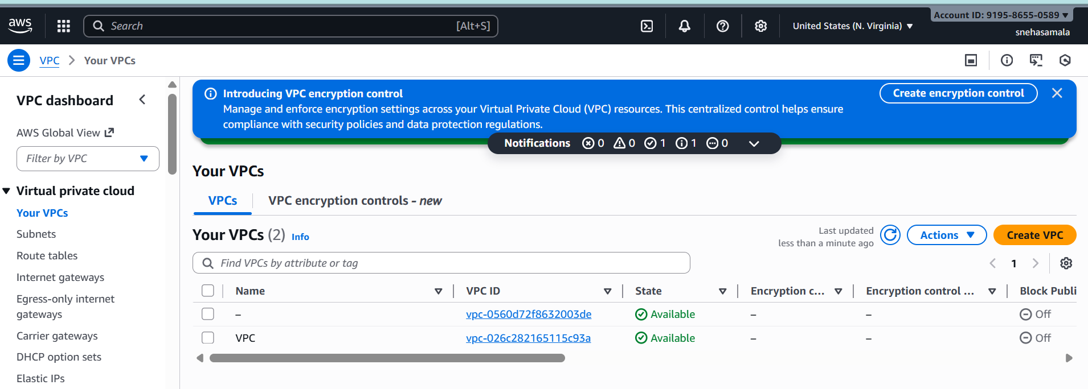

Created 2 public subnet and 2 private subnet

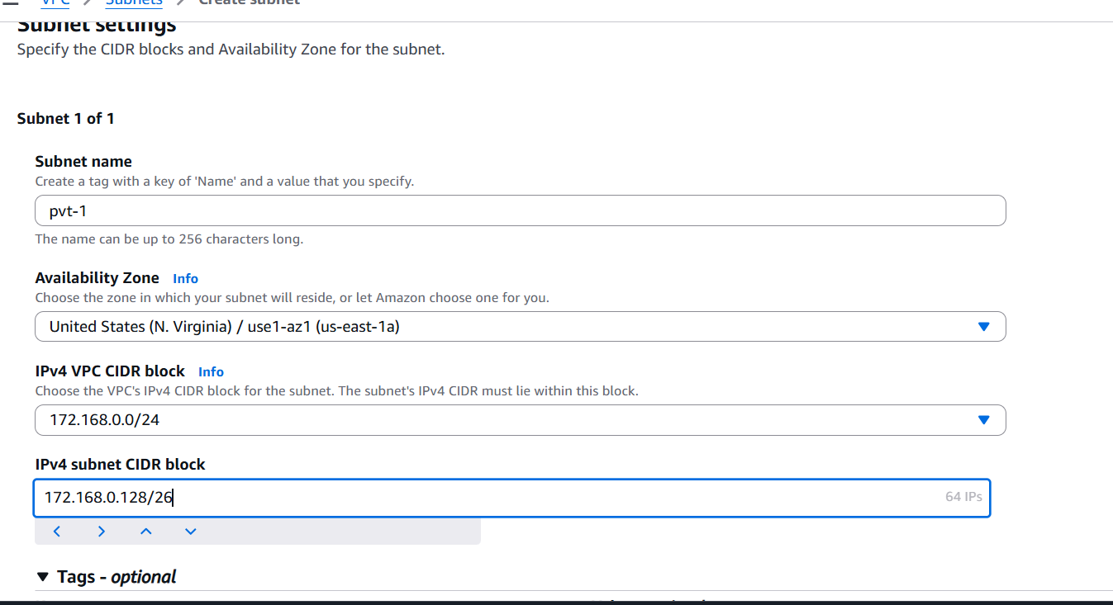

Successfully subnets was created

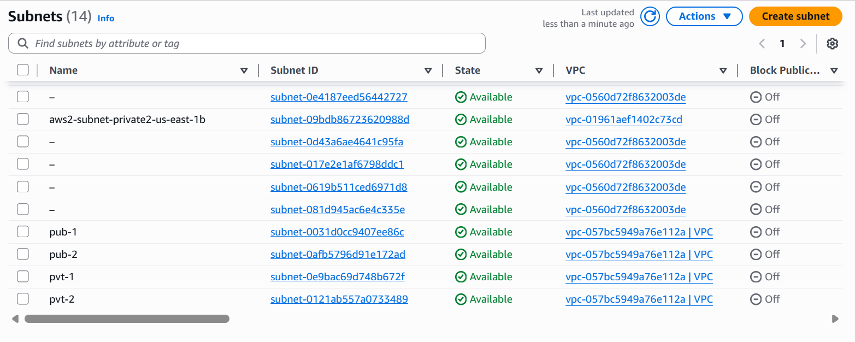

1. Enable DNS Hostname in vpc

Go to your vpc what you have created

Select the vpc and then click to the actions and select the edit VPC

And enable DNS hostname and click and save it

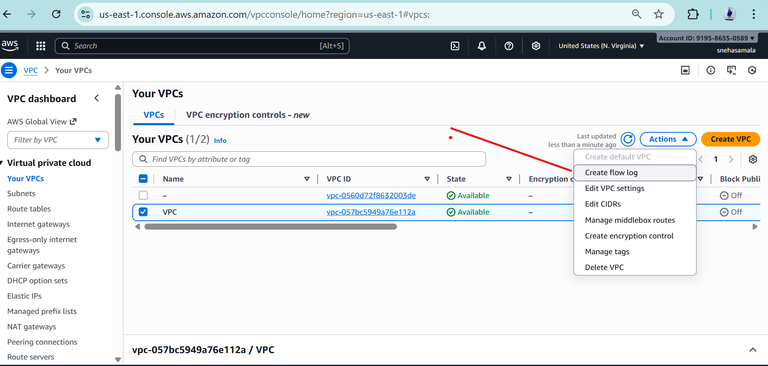

1. Enable Auto Assign Public IP in 2 public subnets.

Go to the

AWS-VPC-SUBNET

Select the subnet and go the actions

Edit subnet setting

Enable auto assign and public IPV4

Tick the checkbox:

And save it

Repeat it again in subnet 2

Select the subnet

Choose subnet

Go to the actions and edit subnet setting

Enable auto-assign IPV4

Click the checkb0x:

Enable auto-assign public IPV4

And save it

Usages of auto assign :

enable auto-assign in public IP give new instance a public IP automatically

this is allow them directly connect to the internet for updates,downloads,and communication

and also let you access those instance from any ssh and browser

mainly we will use for internet

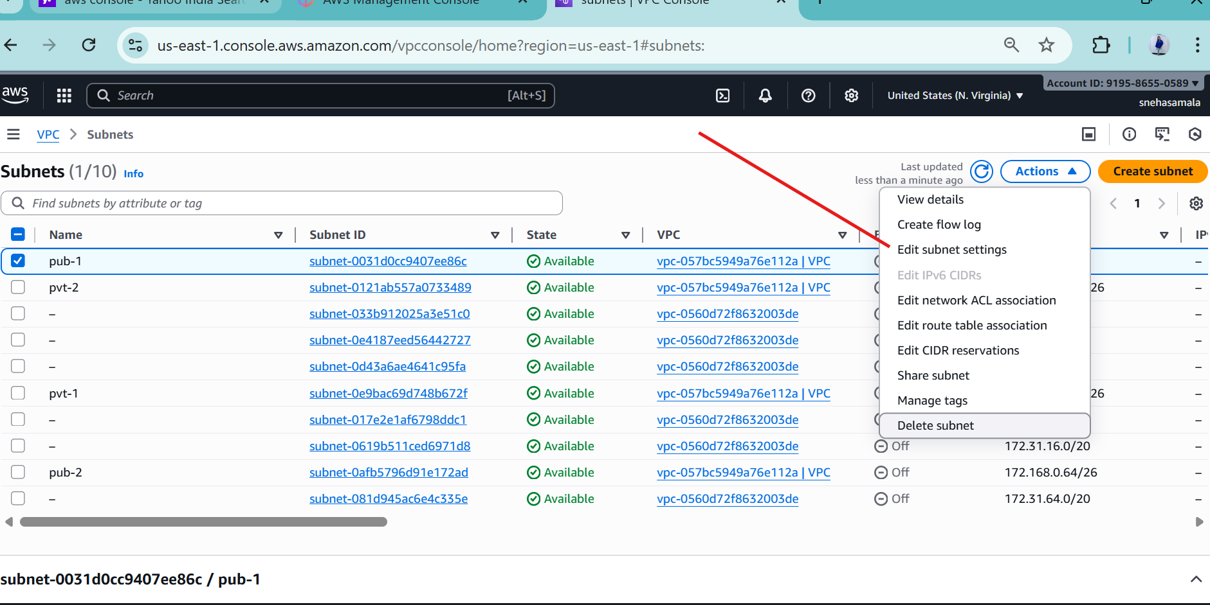

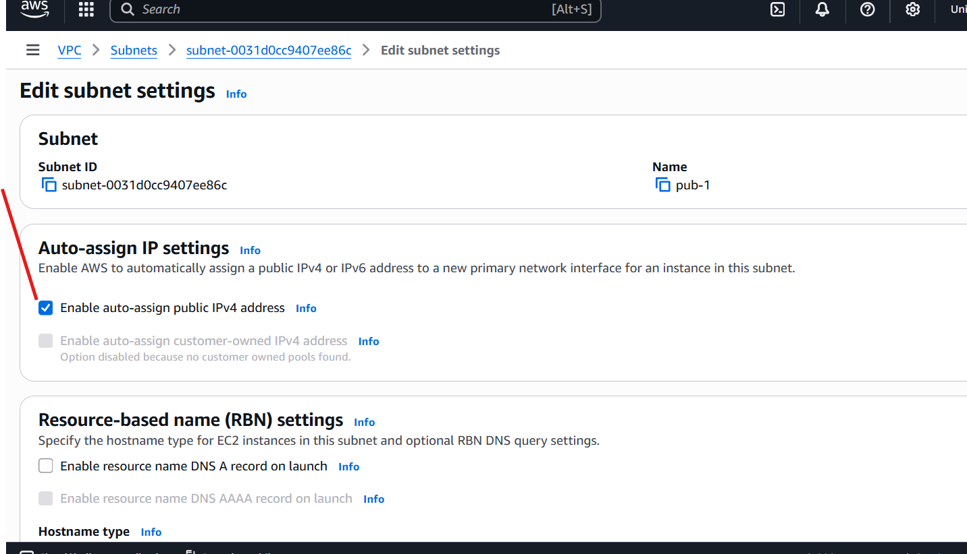

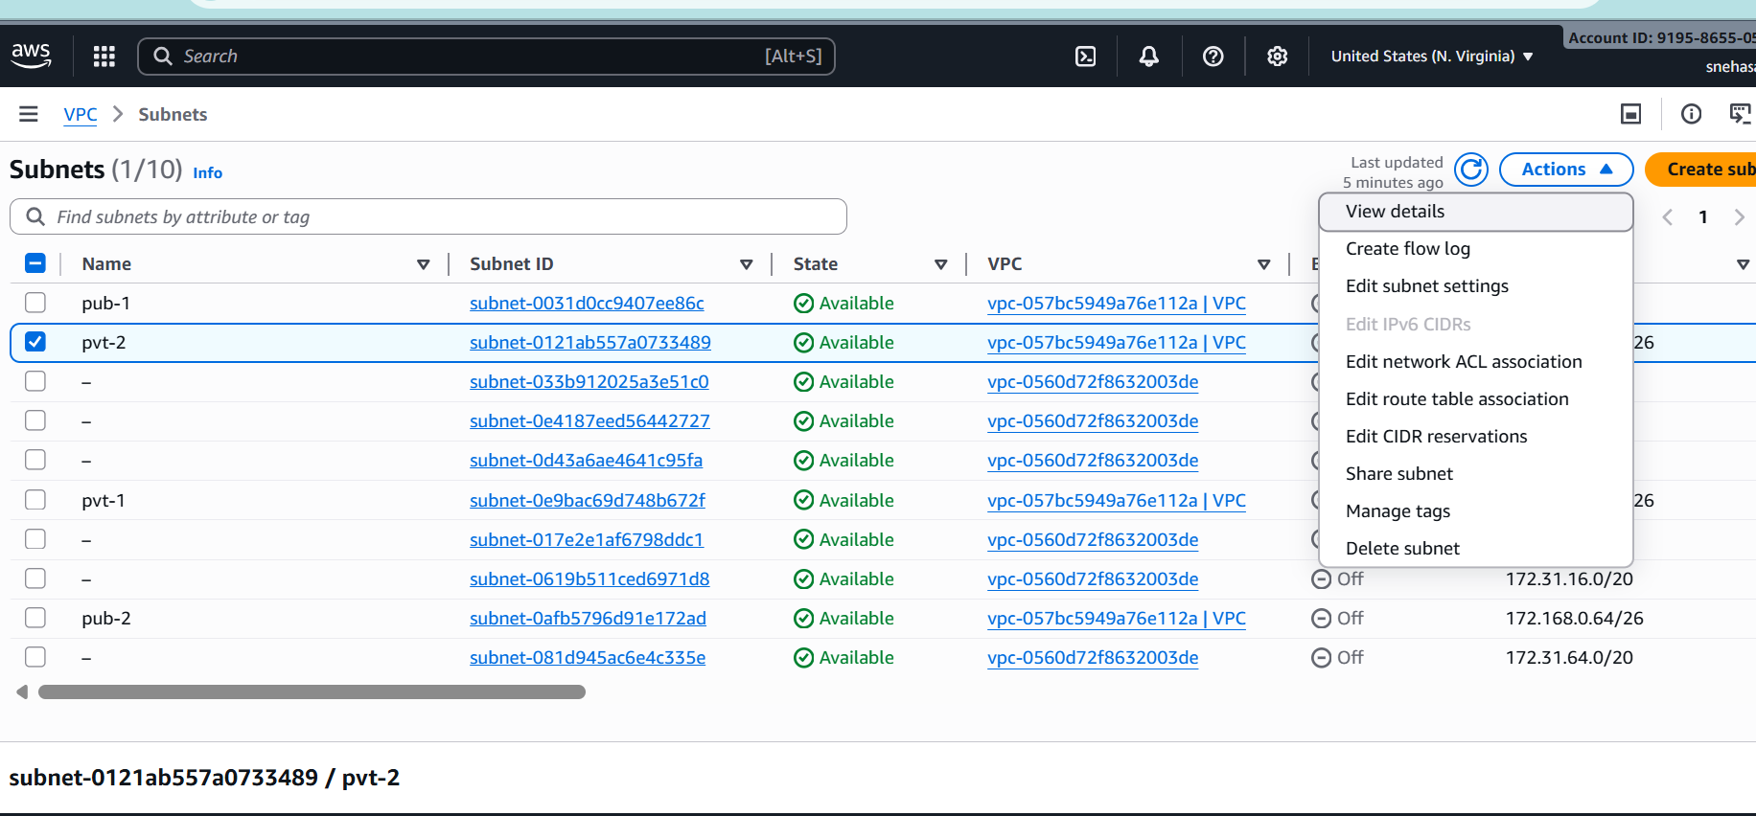

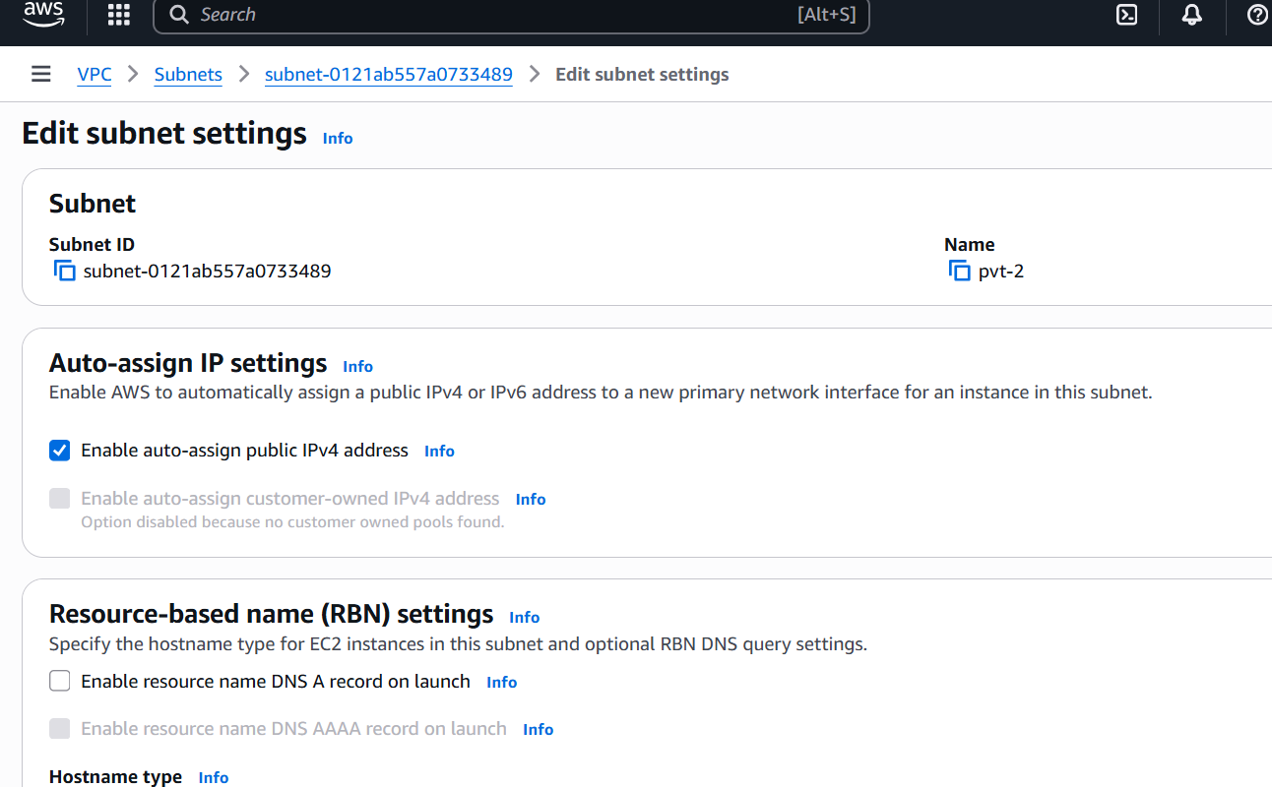

1. Add 2 private subnets in private route table.

Step 1 : go to rout table

Open aws consol-VPC-rout table

Step-2 : select rout table

Step-3 open subnet associations

In the bottom panel : select subnet associations tab

Click edit subnet associations

Step -4 : select private subnet

Private IPV4-1

Private IPV4-2

Step-5 :save

Save the assocations

Subnet private are attached to private rout table

Usages of this :

**To they stay isolated from the internet and route traffic through the NAT gateway.**

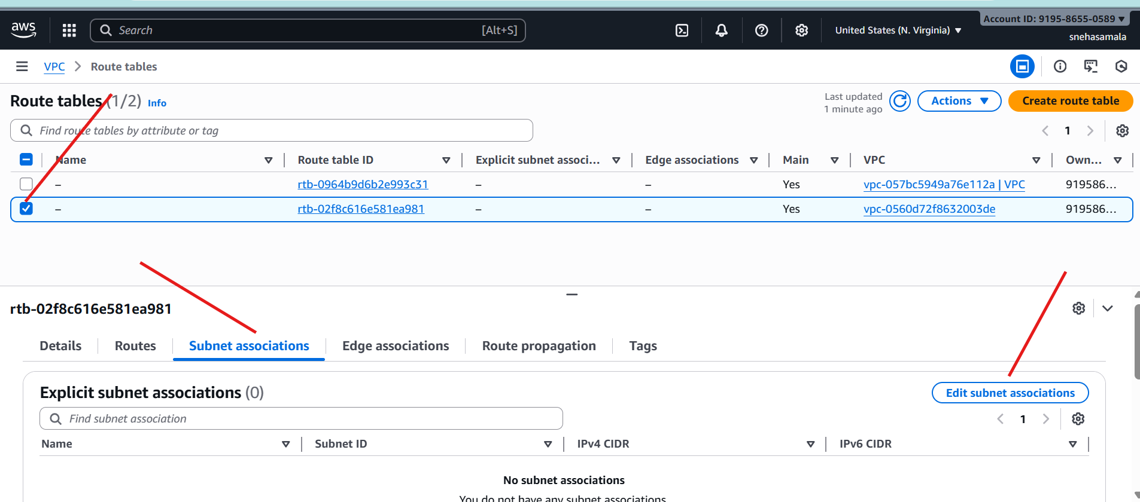

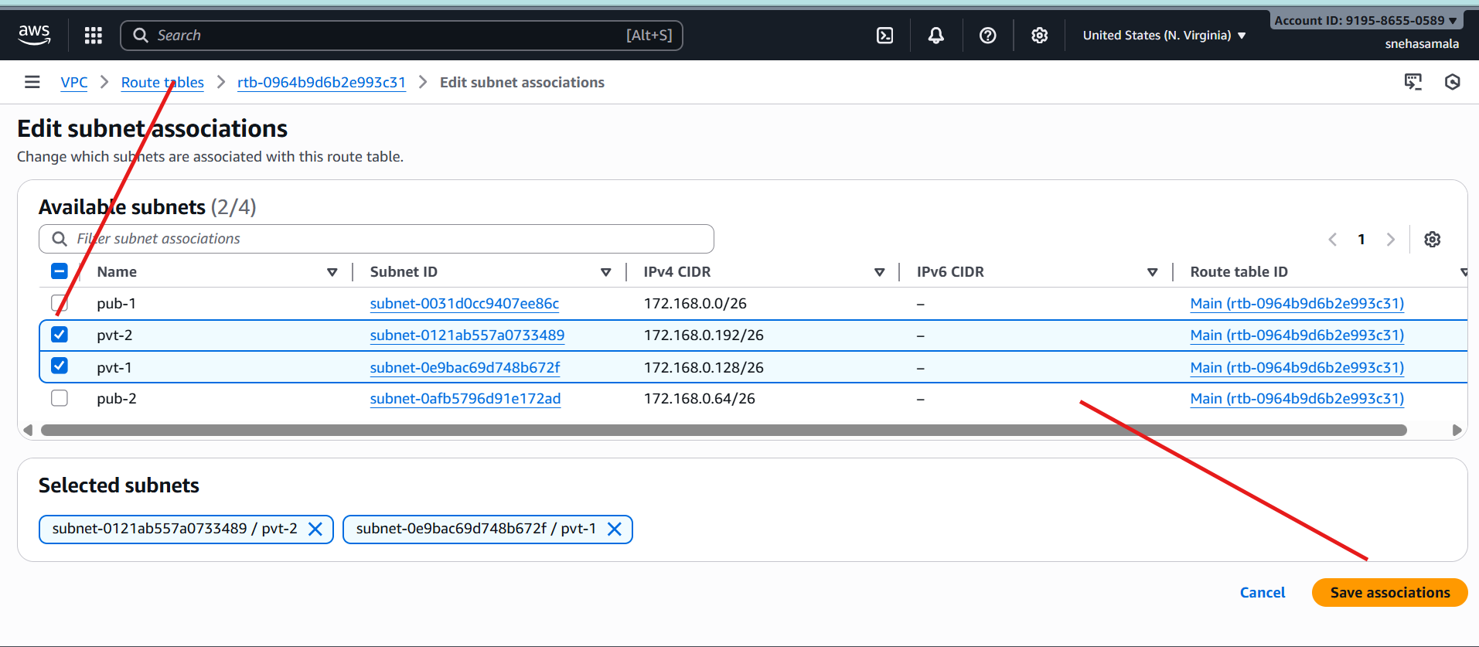

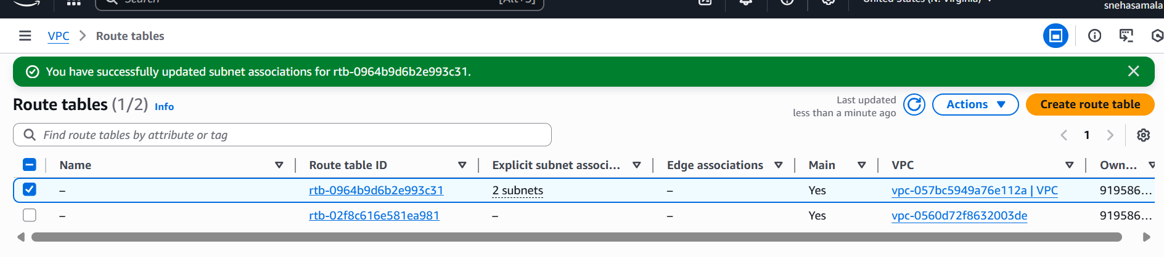

1. Add 2 public subnets in public route table.

STEP-1: go to route table

Open aws console-vpc-routable

STEP-2: Select your route table

STEP-3 open subnet associations

In the bottom panel – select subnet association tab.

Click EDIT subnet associations .

STEP-4 : Select both public subnet

Tick the checkboxes for.

Public-Subnet -01

Public-subnet-02

STEP-5 :save

Click save association

USAGES OF DOING THIS

public subnets need a route to the Internet Gateway.

The public route table contains that internet route.

So we attach the subnets to this route table to give them internet access.

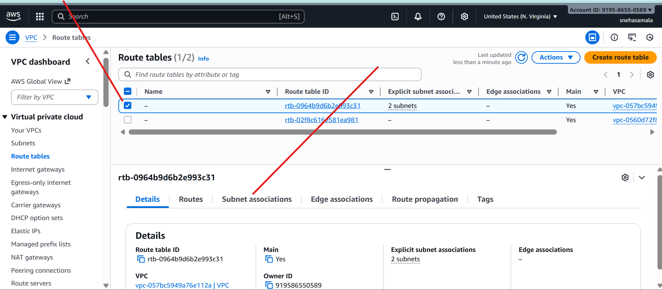

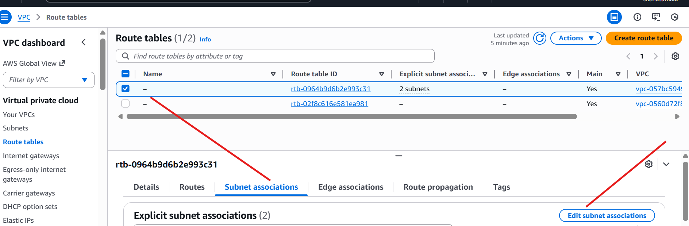

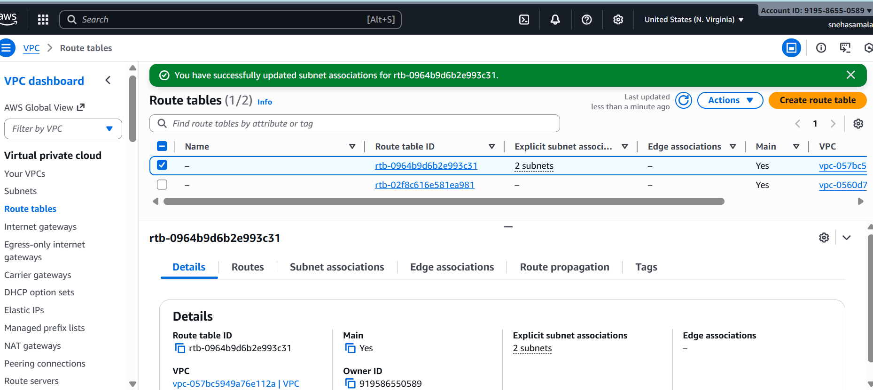

1. Public route table will have the routes to internet and local.

Go to VPC – internet gateway

Click create internet gateway

Give the name of internet

After creating – select it

Go to actions-attach VPC

Choose your VPC-attach’

VPC-ROUTABLE-PUBLIC-RT-ROUTS-EDIT ROUTS-

ADD

Destination

On target

Select IP 0.0.0.0/0 : select internet gateway

USAGES : **It provides internet access through the IGW and allows internal communication within the VPC.**

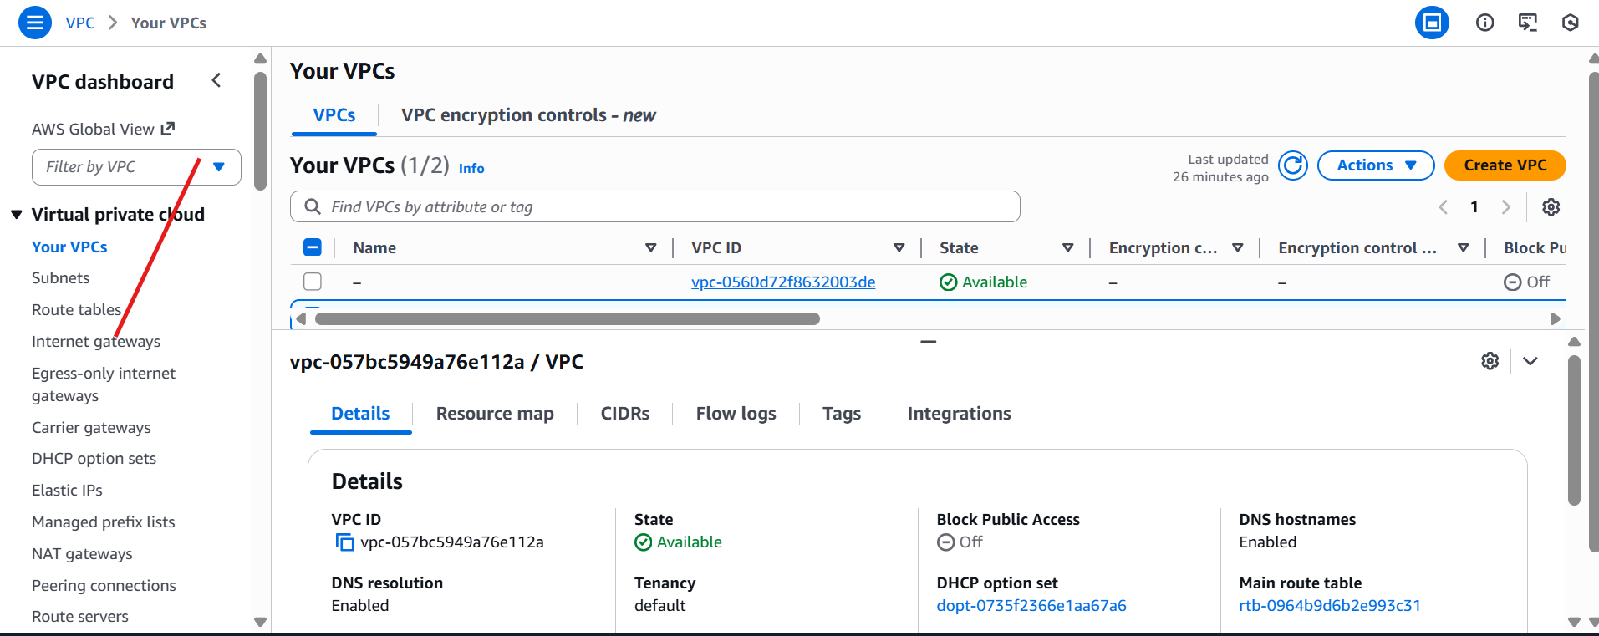

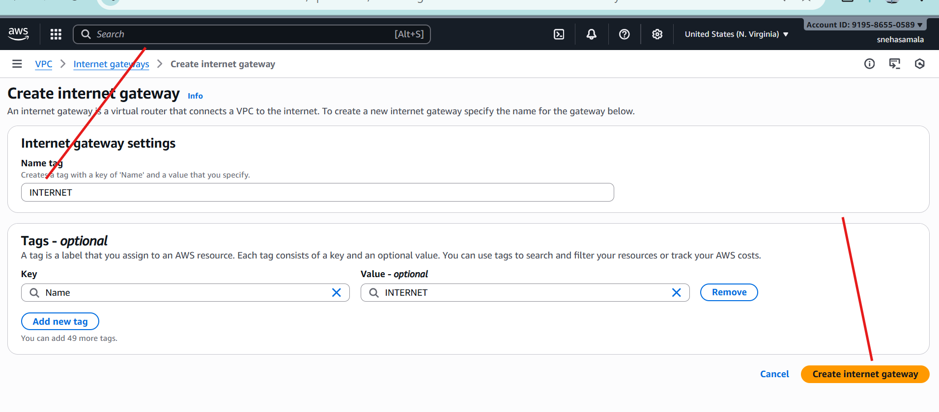

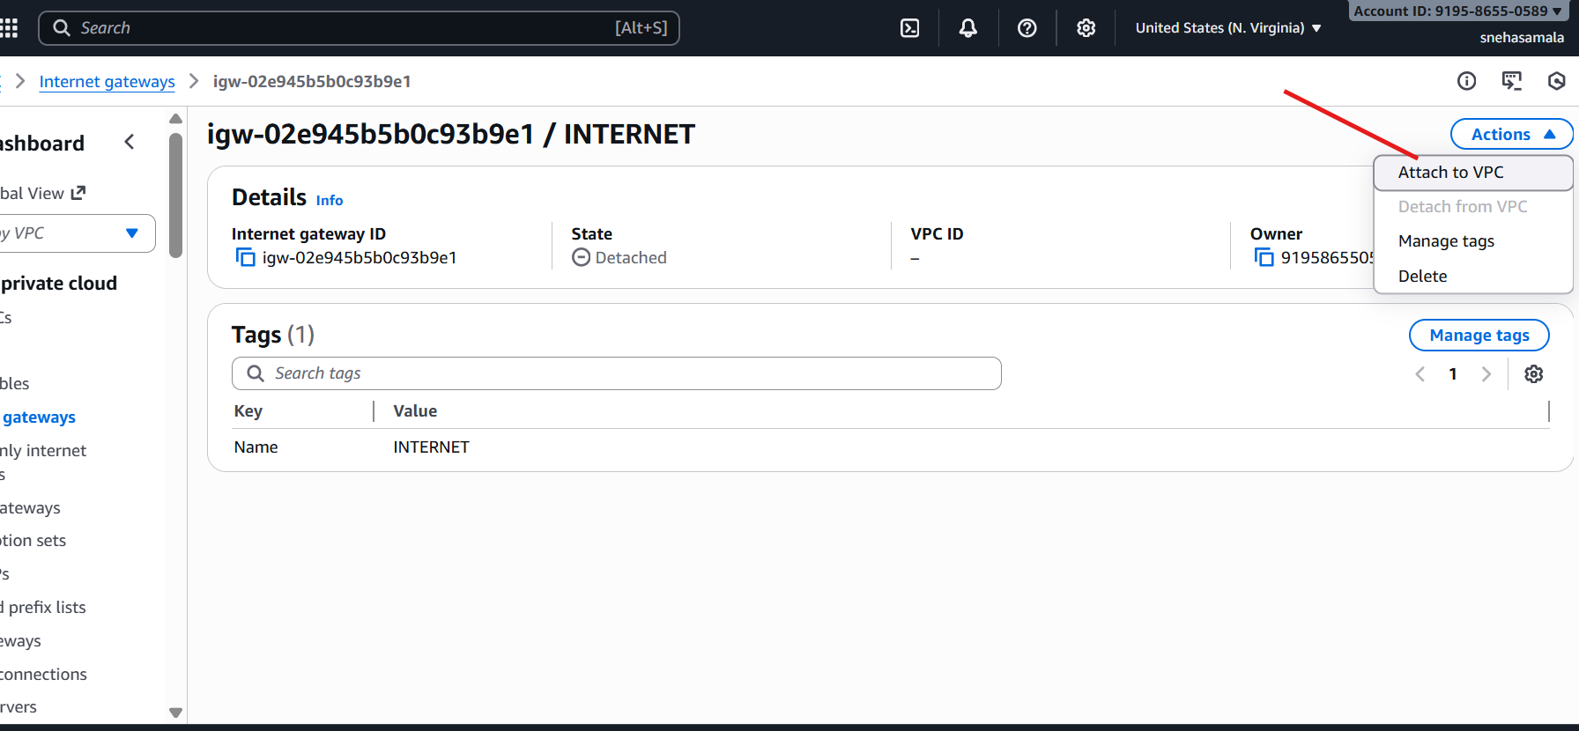

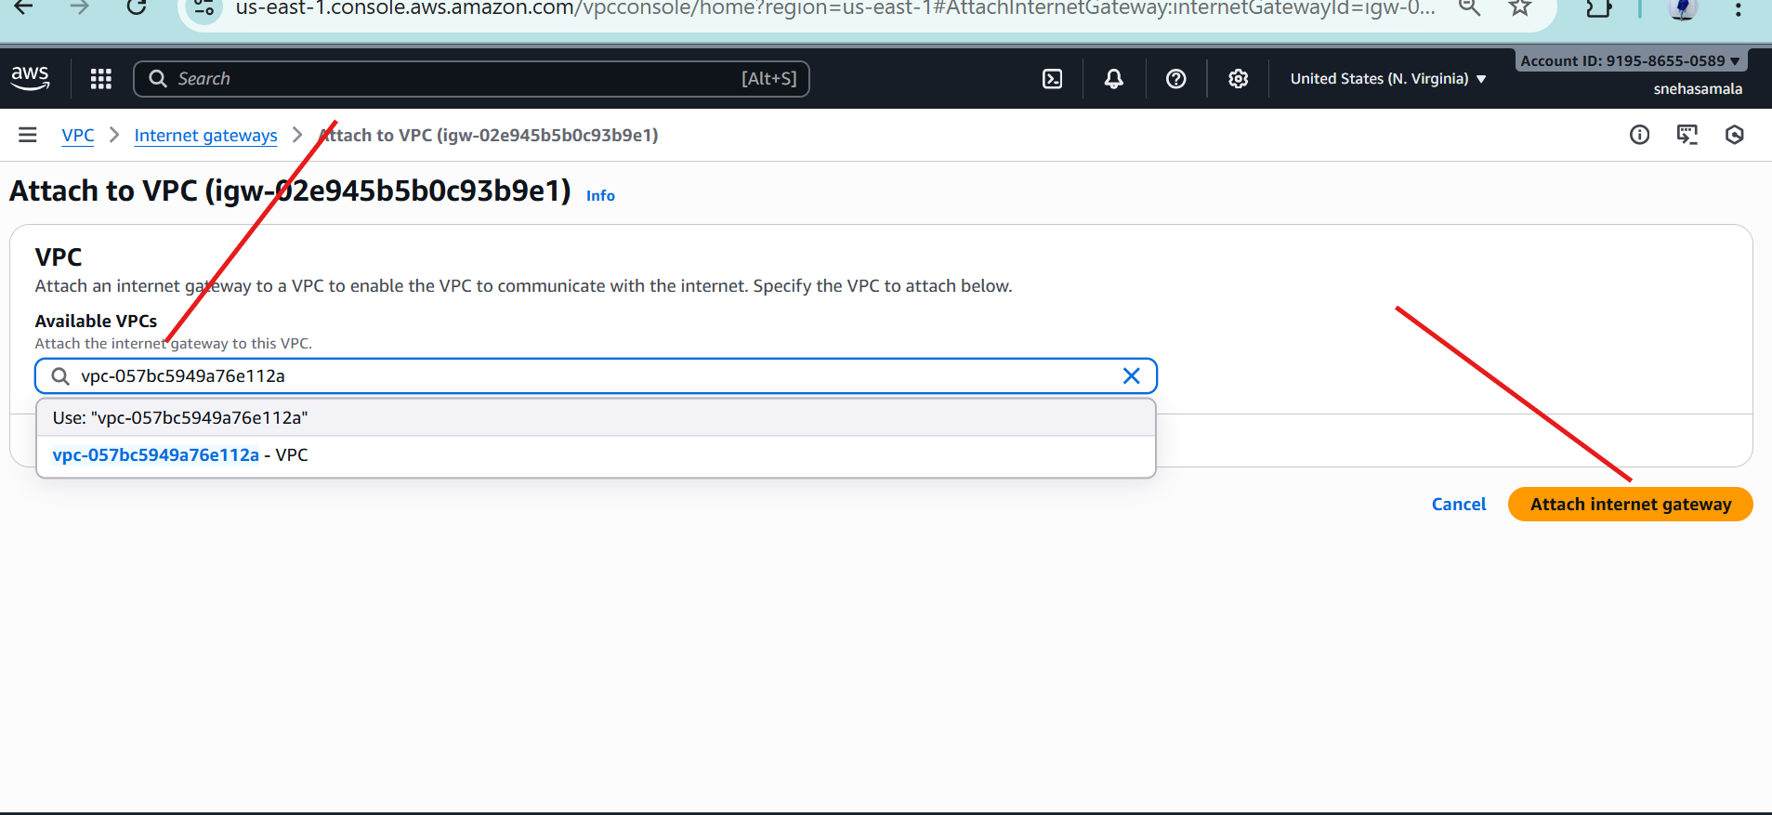

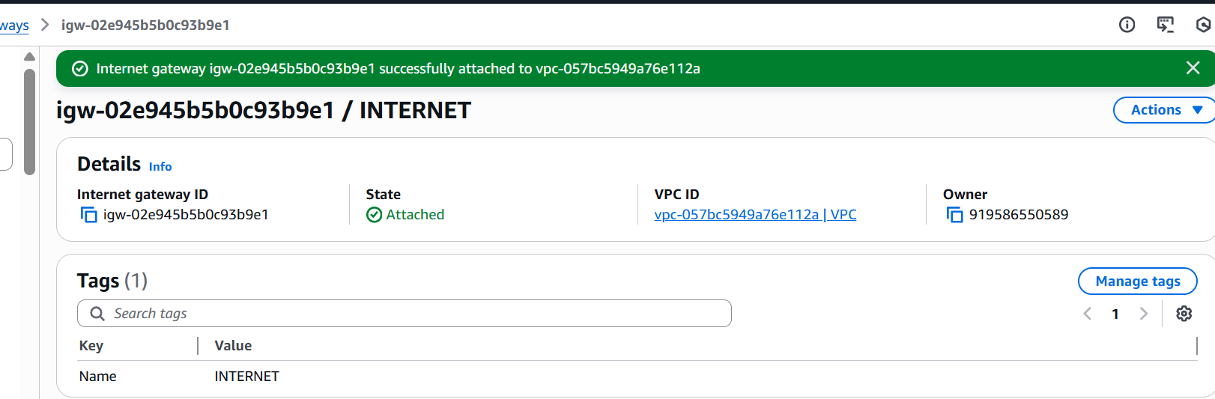

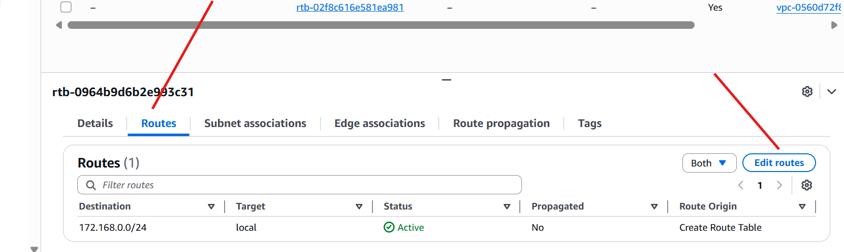

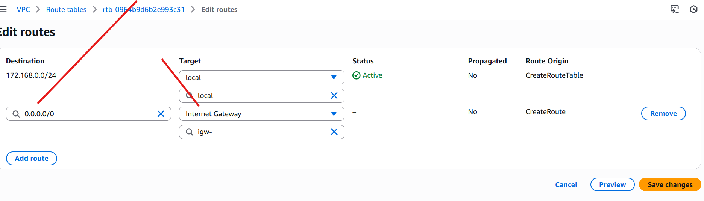

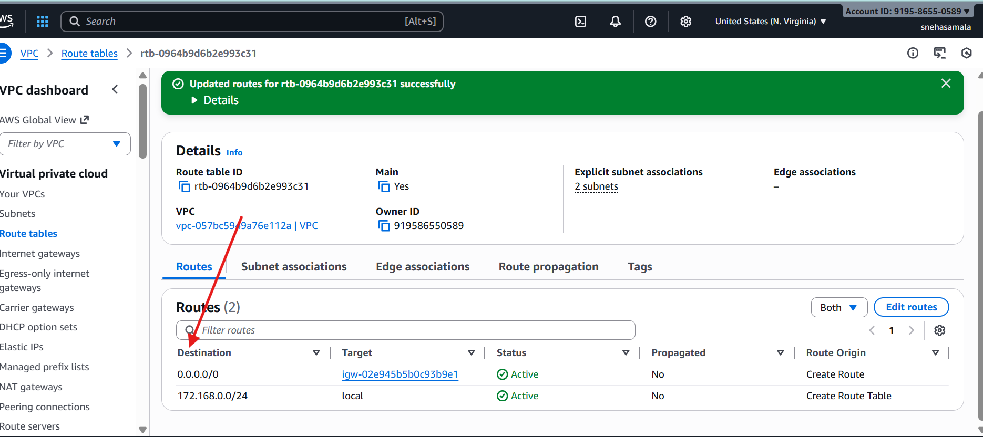

1. Create EC2 in public subnet with t2.micro and install PHP.

Go to Aws

Launch one instance : select the one name to the instance

Give operating system (AMI)

In the networking settiings .choose VPC and select the public IP

In security groups add the inbounds rules

SSH (PORT:22)

HTTP(PORT:80)

And connect to the terminal

Successfully connected

Go to the root user

Sudo update -y

Sudo yum install httpd -y

Sudo systemctl status httpd

Sudo syste,ctl status httpd (activated httpd)

Sudo yum install php php-cli php-mysqlnd -y

Sudo systemctl restart httpd

Them browse with your IP address

Its working

Why we do this

To host and run a PHP-based web application that can be accessed from the internet.

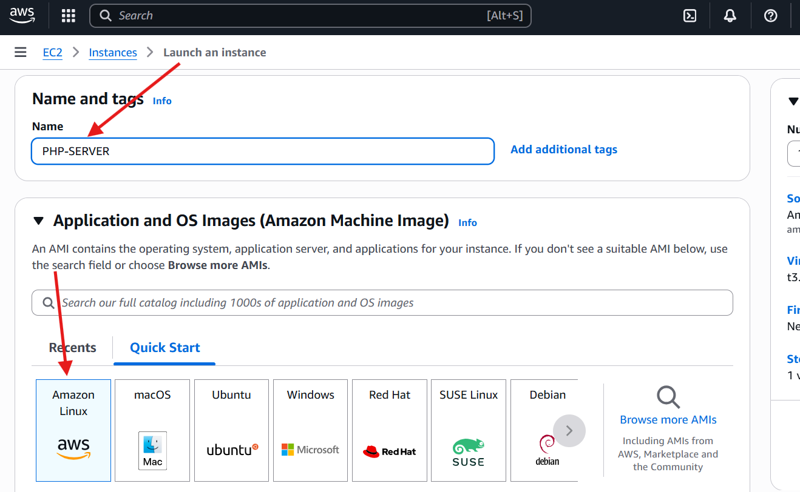

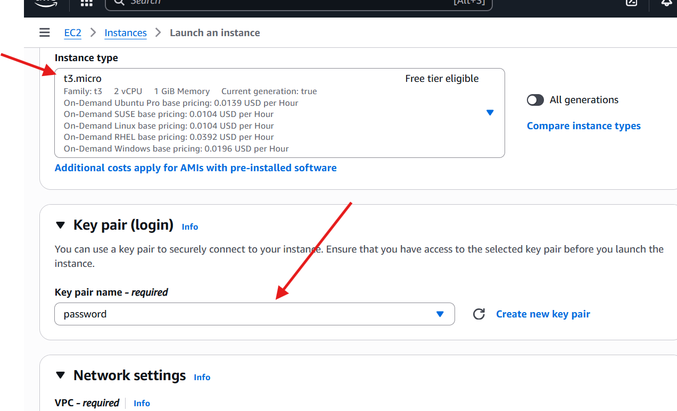

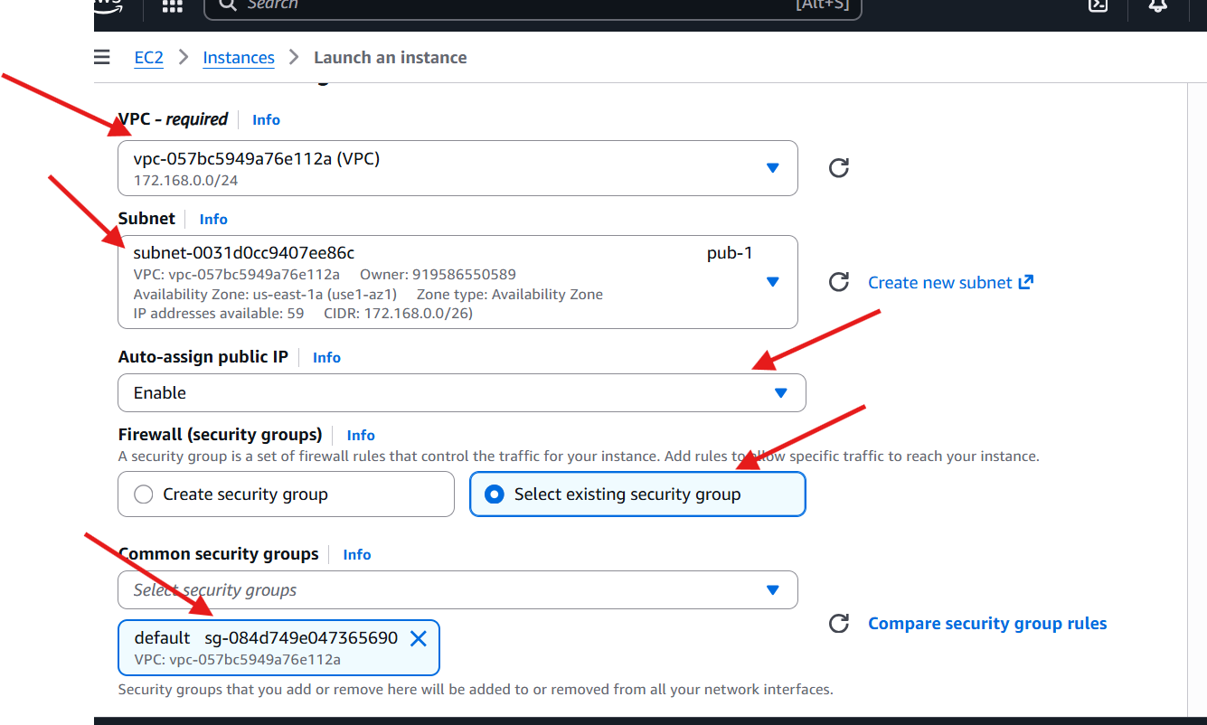

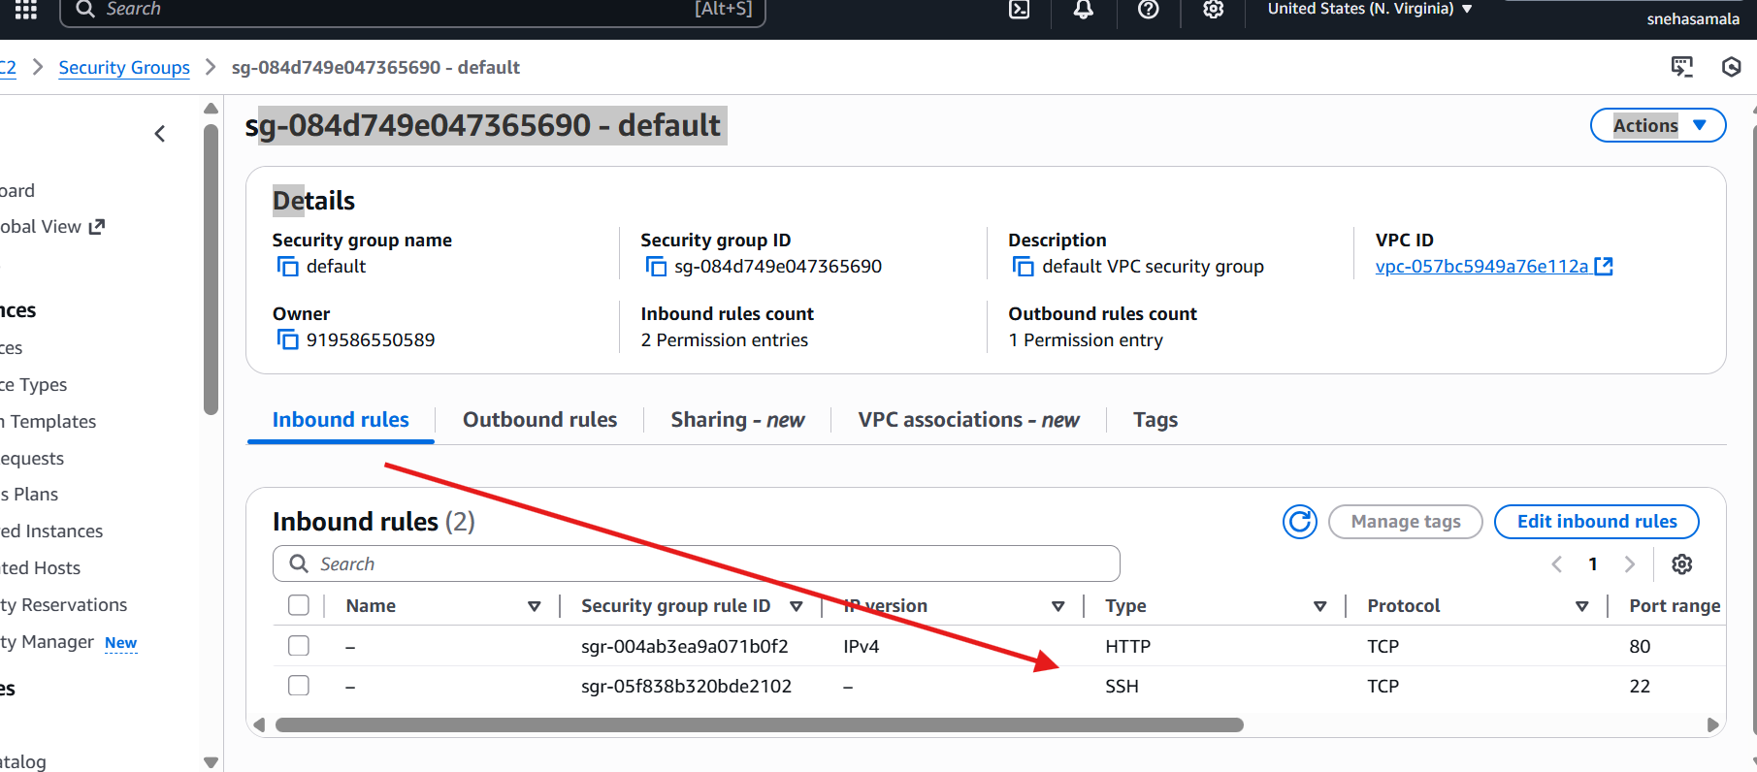

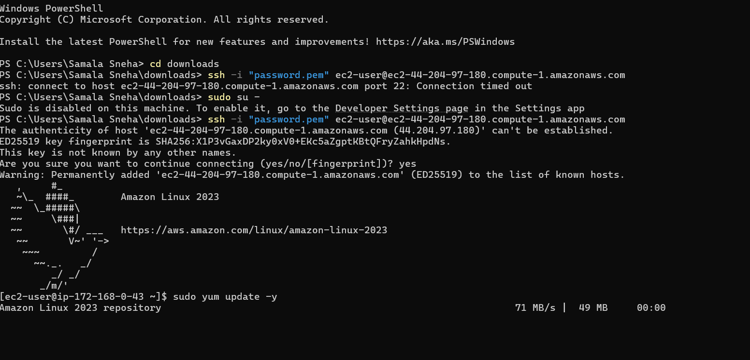

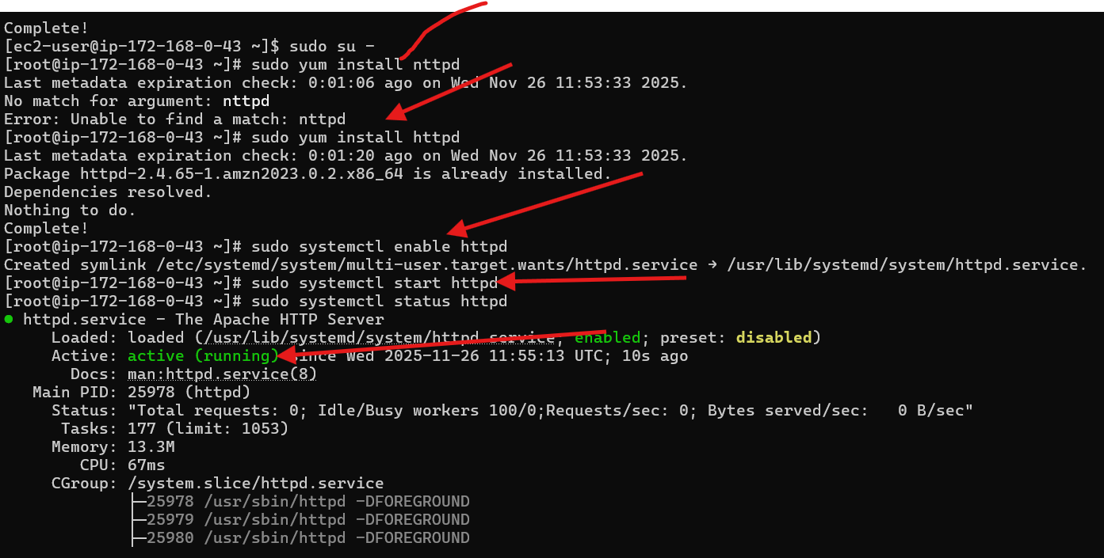

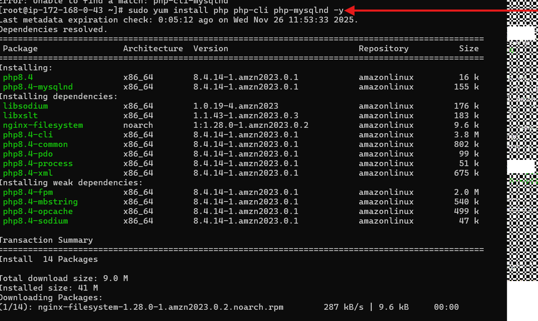



1. Configure NAT gateway in public subnet and connect to private instance.

**. Allocate an Elastic IP (EIP)**

* Go to **VPC Dashboard** → **Elastic IPs**.
* Click **Allocate Elastic IP address** → Choose

**Create the NAT Gateway**

* Navigate to **VPC Dashboard** → **NAT Gateways**.
* Click **Create NAT Gateway**.
* Select the **public subnet** where the NAT Gateway will be deployed.
* Assign the previously allocated **Elastic IP** to the NAT Gateway.
* Click **Create NAT Gateway** and wait for its status to become "Available."

**Update the Private Route Table**

* Go to **VPC Dashboard** → **Route Tables**.
* Select the route table associated with your private subnets.
* Click **Edit Routes** and add a route with the following:
  + **Destination:** 0.0.0.0/0 (all internet traffic)
  + **Target:** Select the **NAT Gateway** you created.

**Associate Private Subnets with the Route Table**

* In the route table, go to **Subnet Associations**.
* Click **Edit Subnet Associations**.
* Select the private subnets to associate with this route table and save

**Verify and Test Connectivity**

* Launch or use an existing EC2 instance in a private subnet.
* Connect to the instance via a Bastion host or AWS Systems Manager.
* Test outbound connectivity by running a command like curl to an external website or updating software packages.

**Verification Checklist**

* **NAT Gateway Status:** Ensure the NAT Gateway is "Available."
* **Route Table Configuration:** Confirm that the route table for private subnets has the default route (0.0.0.0/0) pointing to the NAT Gateway.
* **Private Instance Access:** Verify that private instances can access the internet but do not have public IPs.

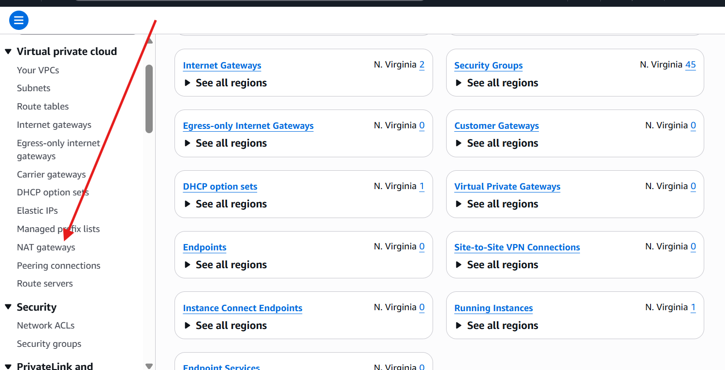

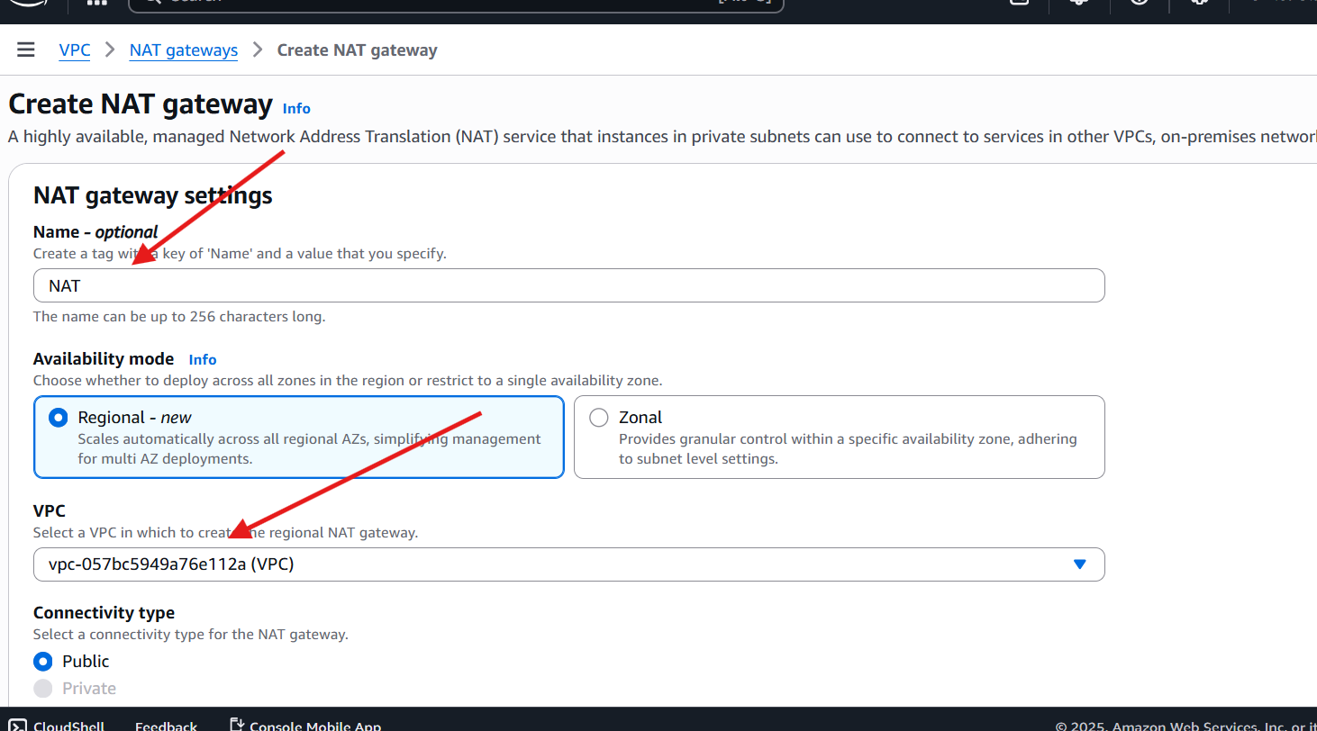

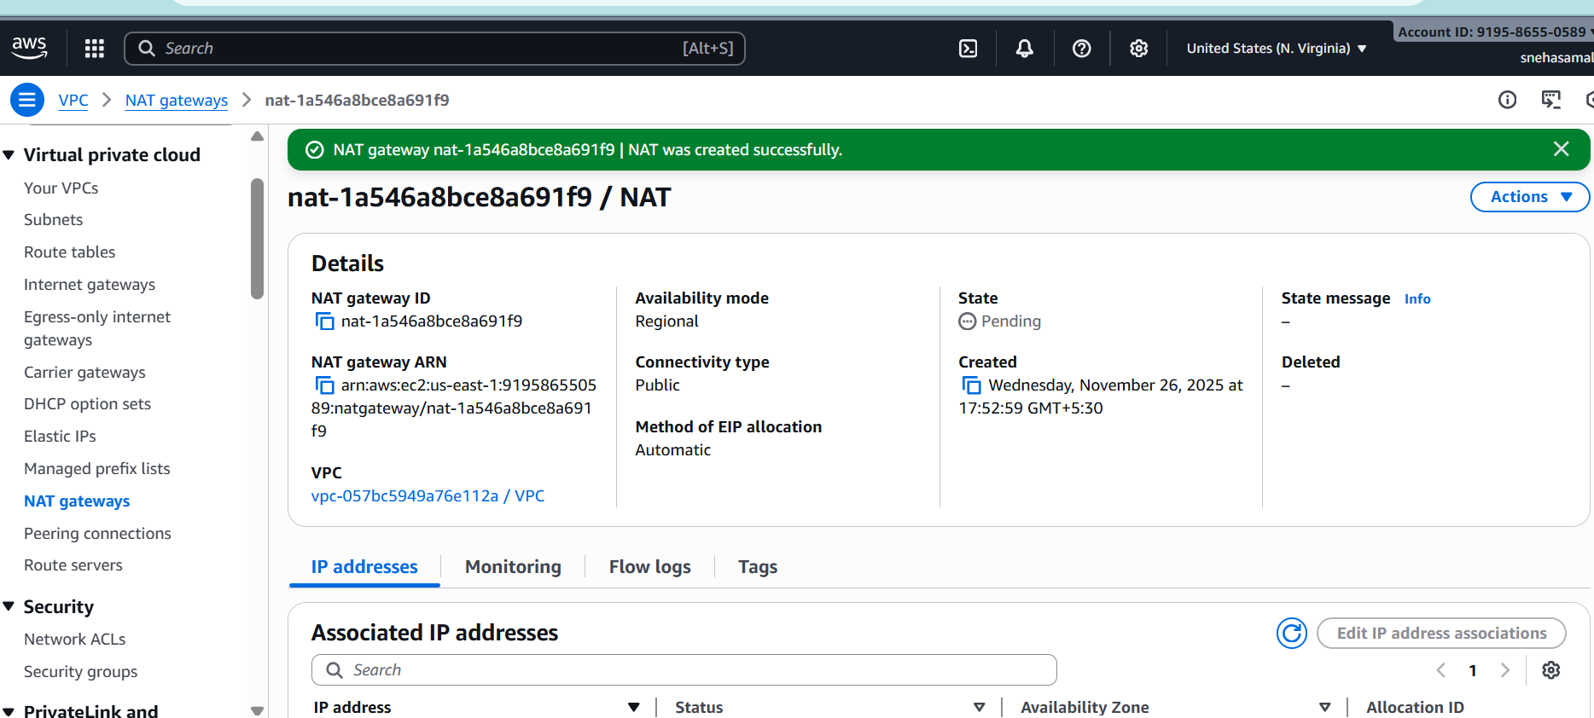

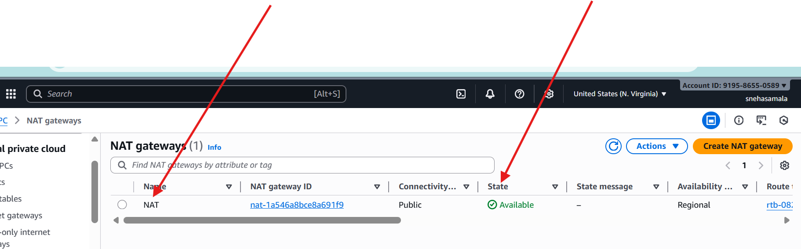

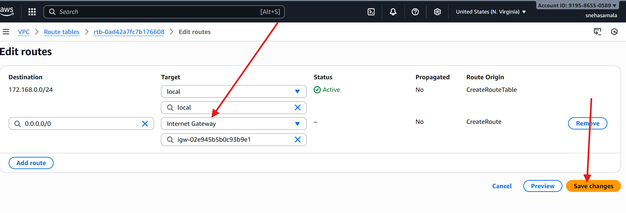

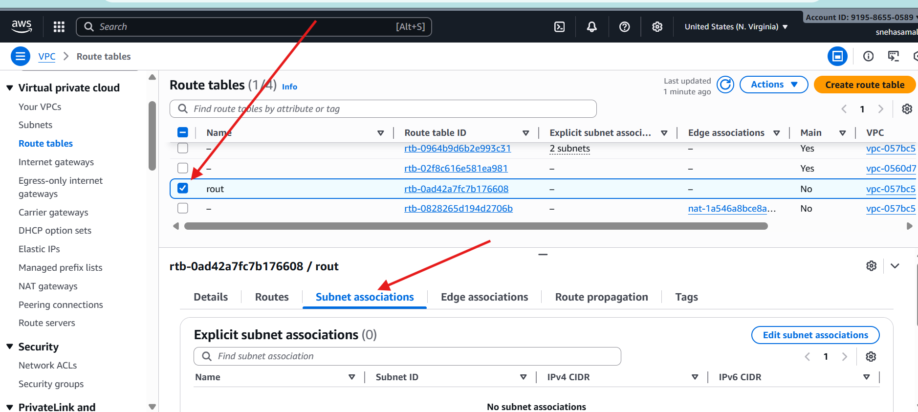

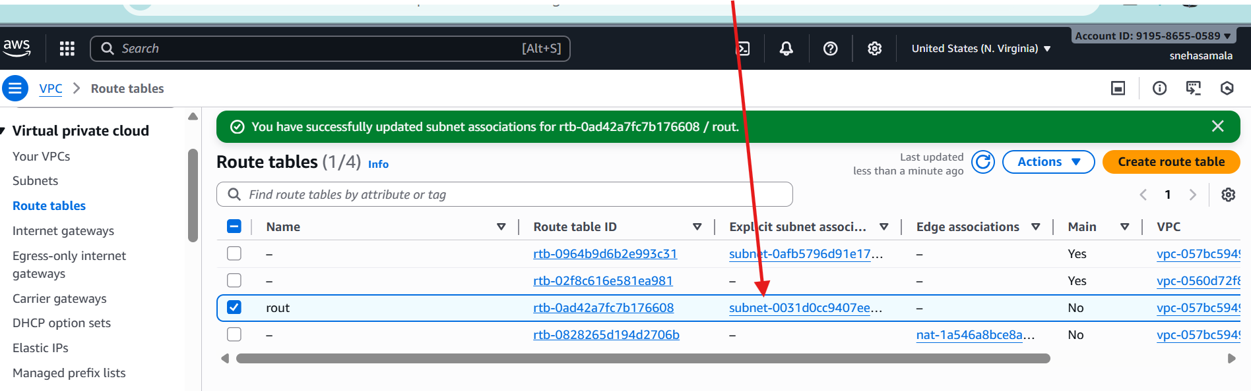

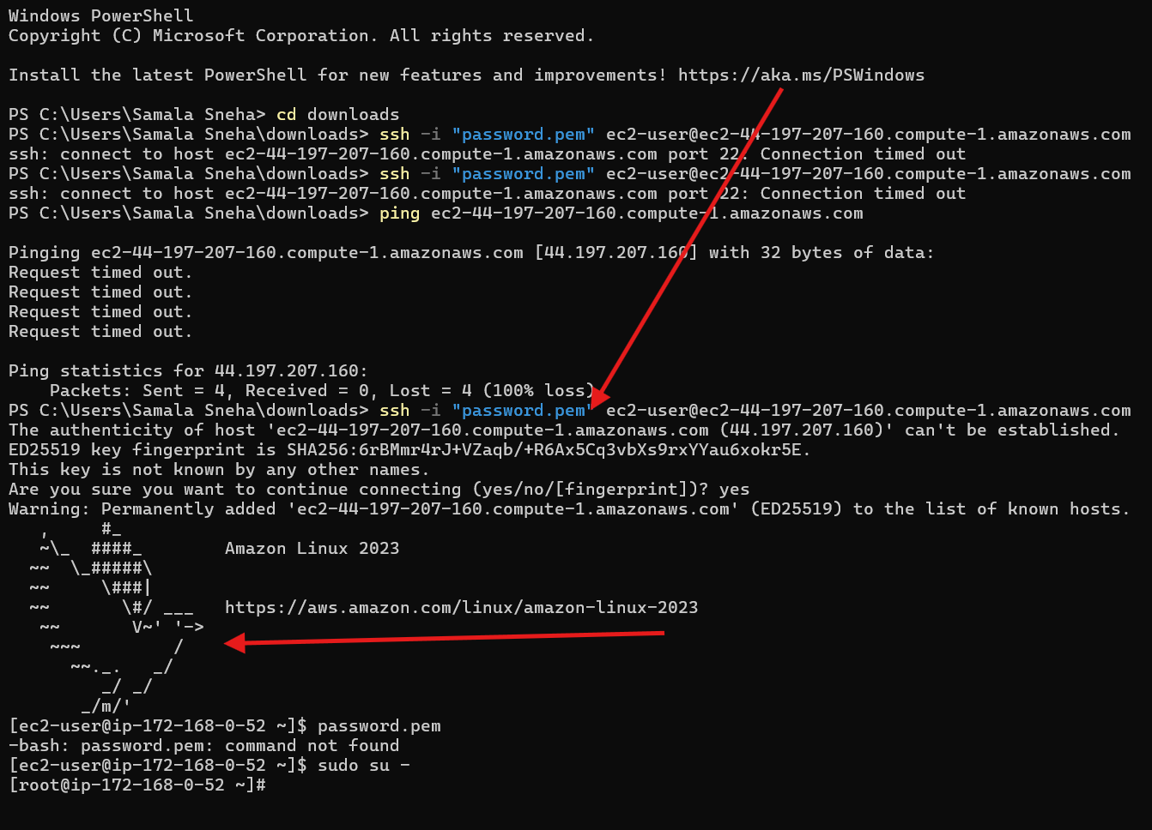

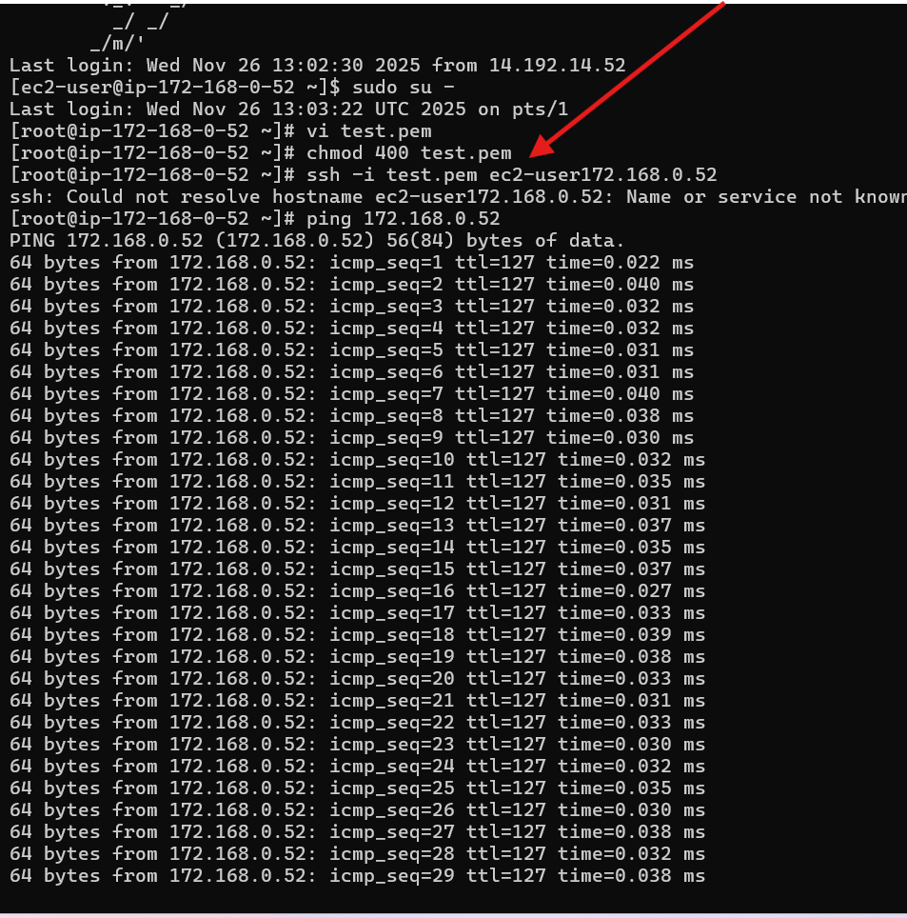

1. Install Apache Tomcat in private EC2 and deploy a sample app.

Connect to the local

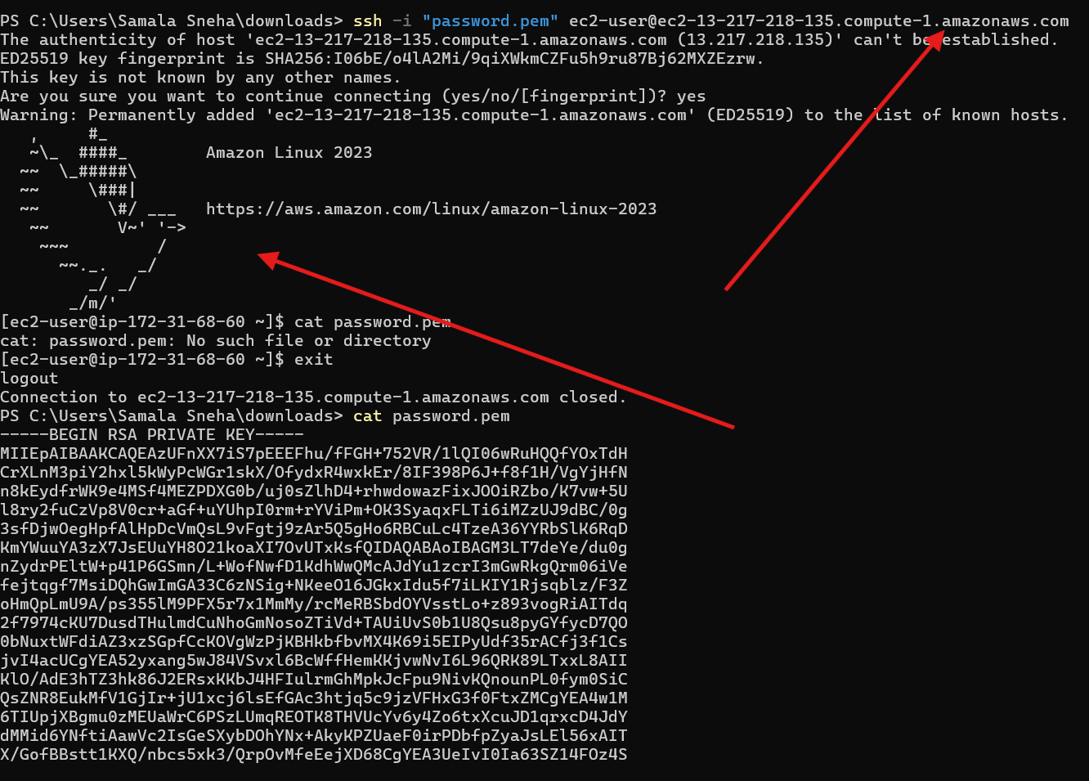

Connected to the private key successfully

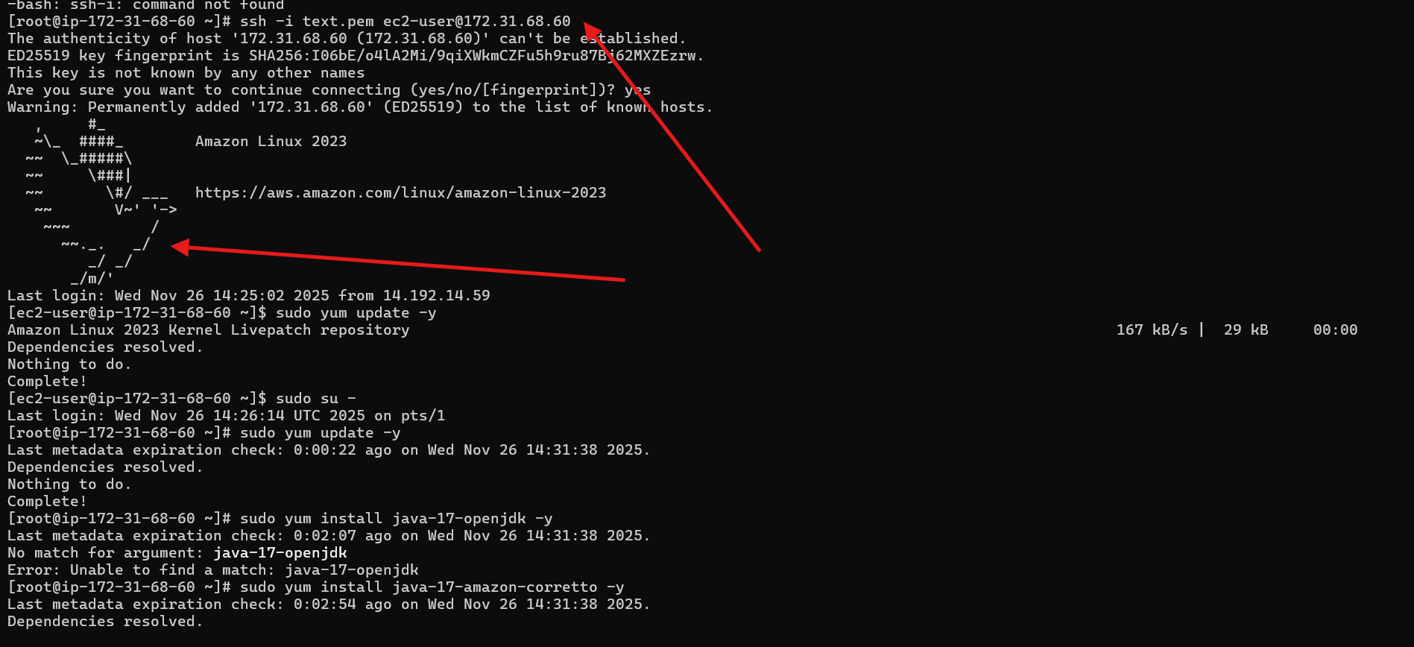

Successfully installed the java

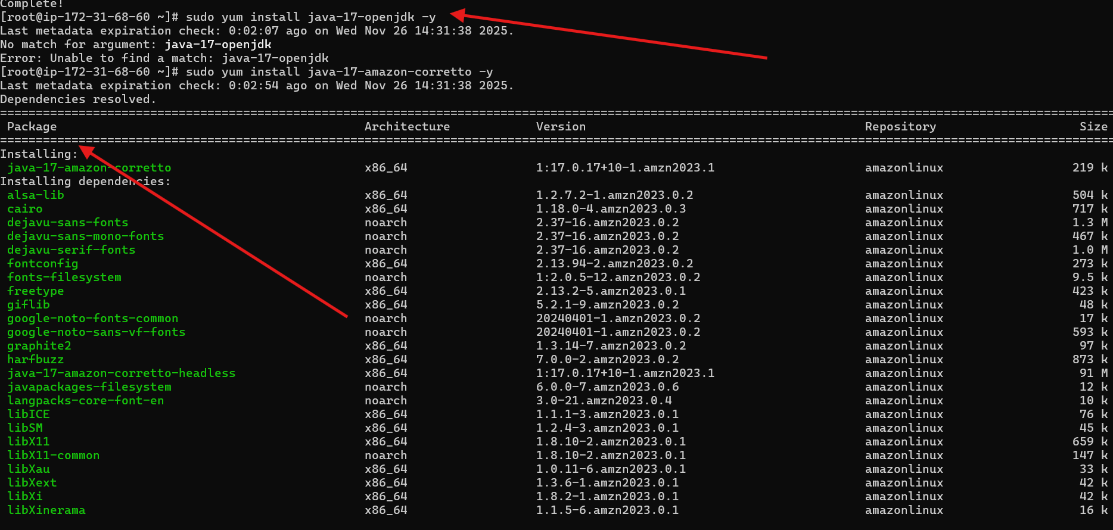

Check the version of java

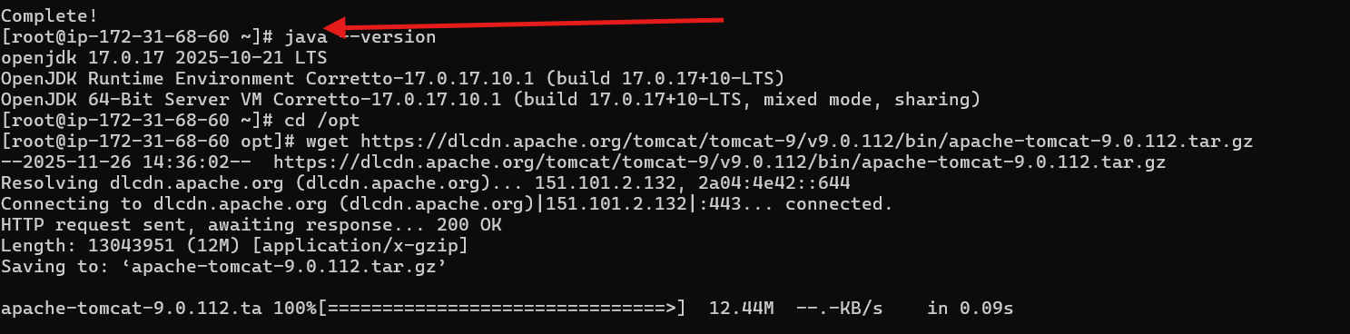

Install the apache tomcat

Wget https://dlcdn.apache.org/tomcat/tomcat-9/v9.0.112/bin/apache-tomcat-9.0.112.tar.gz

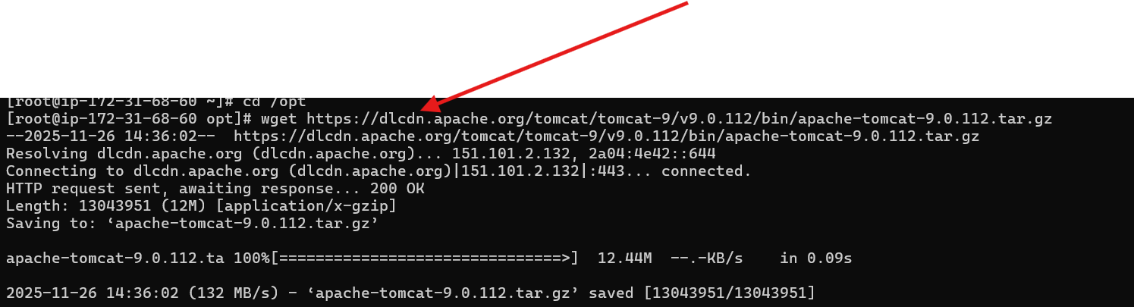

Sudo tar -xvf apache-tomcat-9.0.112.tar.gz : extracting the file

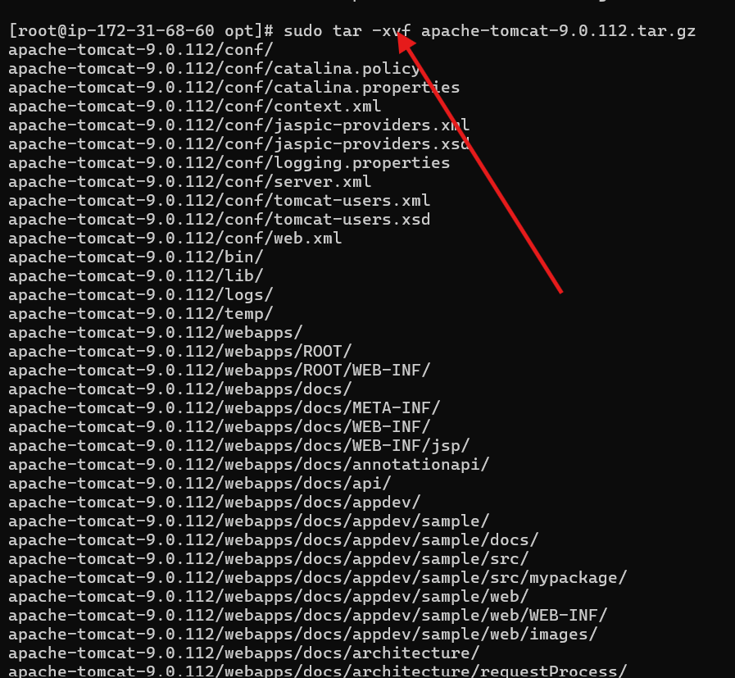

Rename the file

Sudo mv apache-tomcat-9.0.112 tomcat

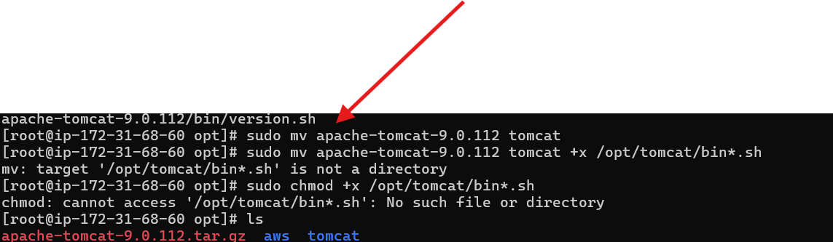

sudo chmod +x /opt/tomcat/bin/*.sh : we are giving executable permissions to files in the bin folder

sudo /opt/tomcat/bin/startup.sh : starting the tomcat

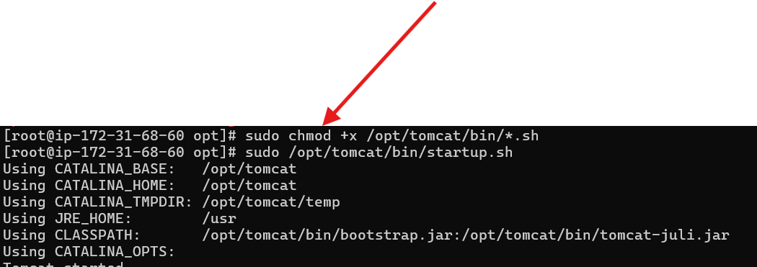

Ps -ef | grep tomcat : checking the system running status

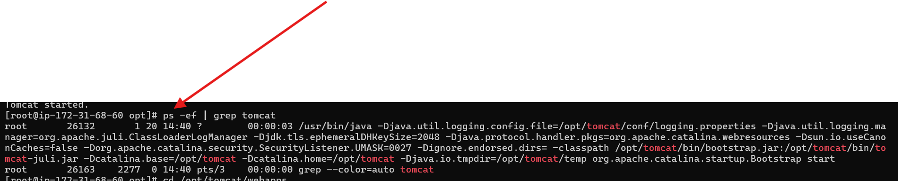

Deploying the sample tomcat file

Go to the browser type : sample application of tomcat

Wget <https://tomcat.apache.org/tomcat-7.0-doc/appdev/sample/sample.war>

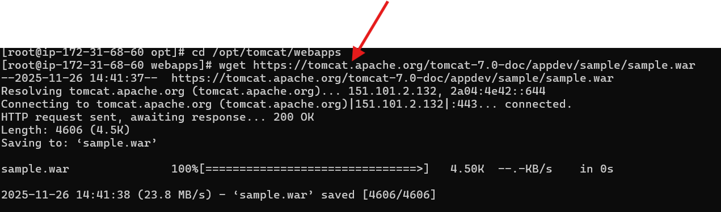

/opt/tomcat/webapps/sample/ : tomcat automatically extract

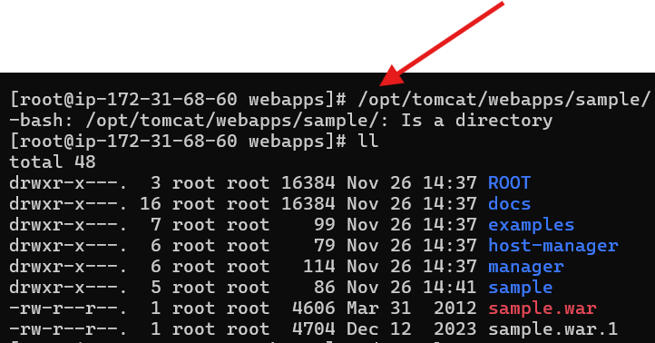

Change the directory : dc sample

Do ls : sample file is came successfully

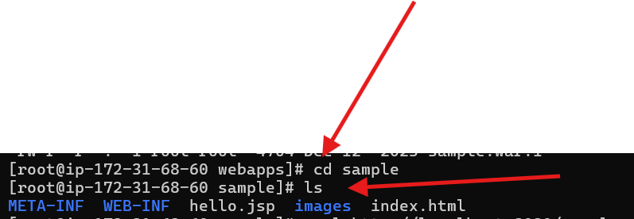

Curl <http://localhost:8080/sample> : sending request to the URL

Curl <public ip>:8080 : Tomcat server is running by sending a request to port 8080 on the private IP.

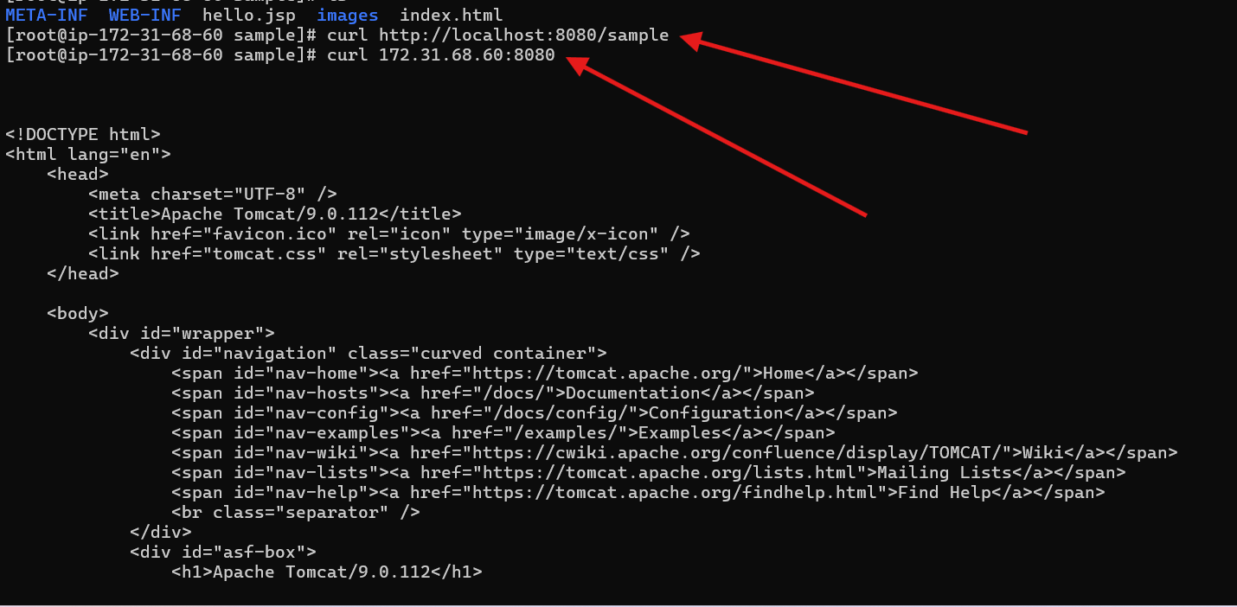

1. Configure VPC flow logs and store the logs in S3 and CloudWatch.

Go to the VPC

Select the vpc

Go to actions – create flow log

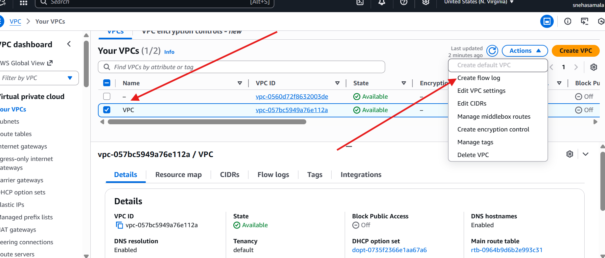

Create the name of flow-log

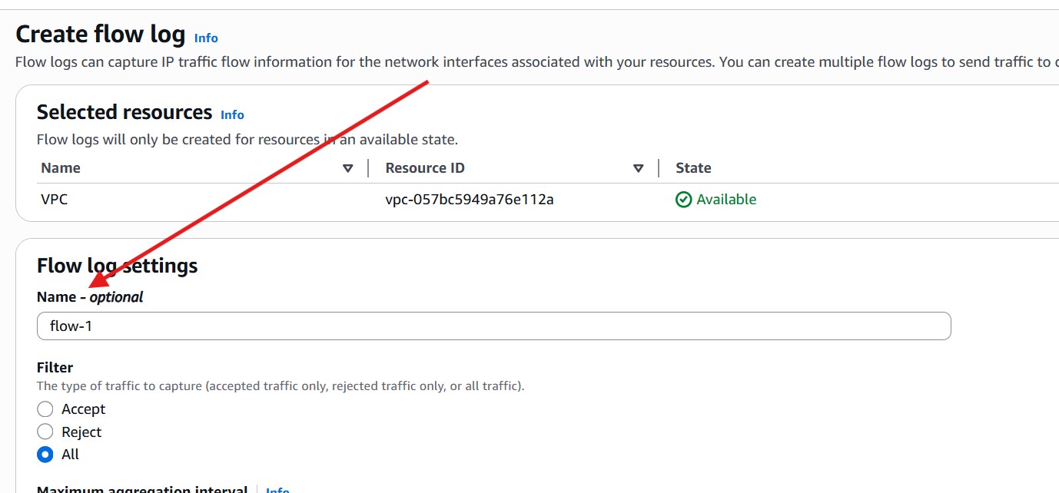

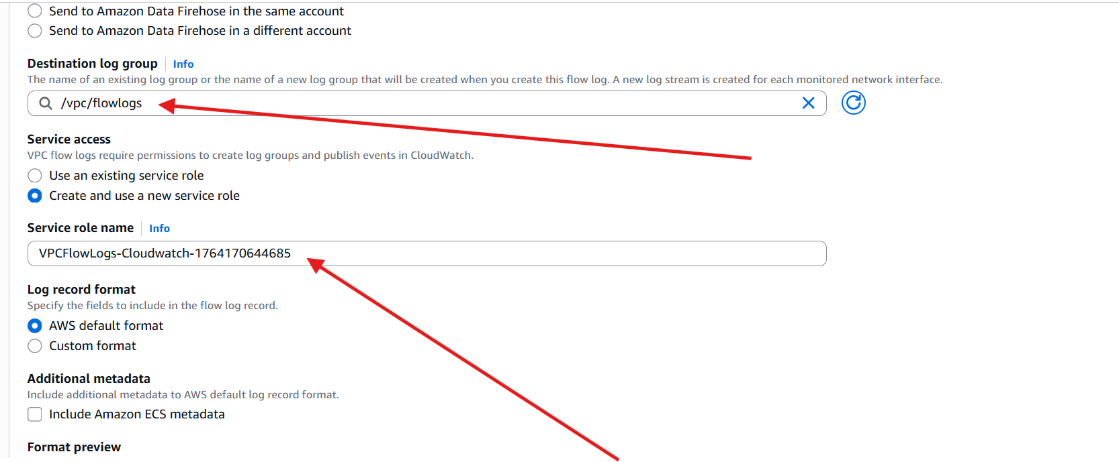

Go to the logs

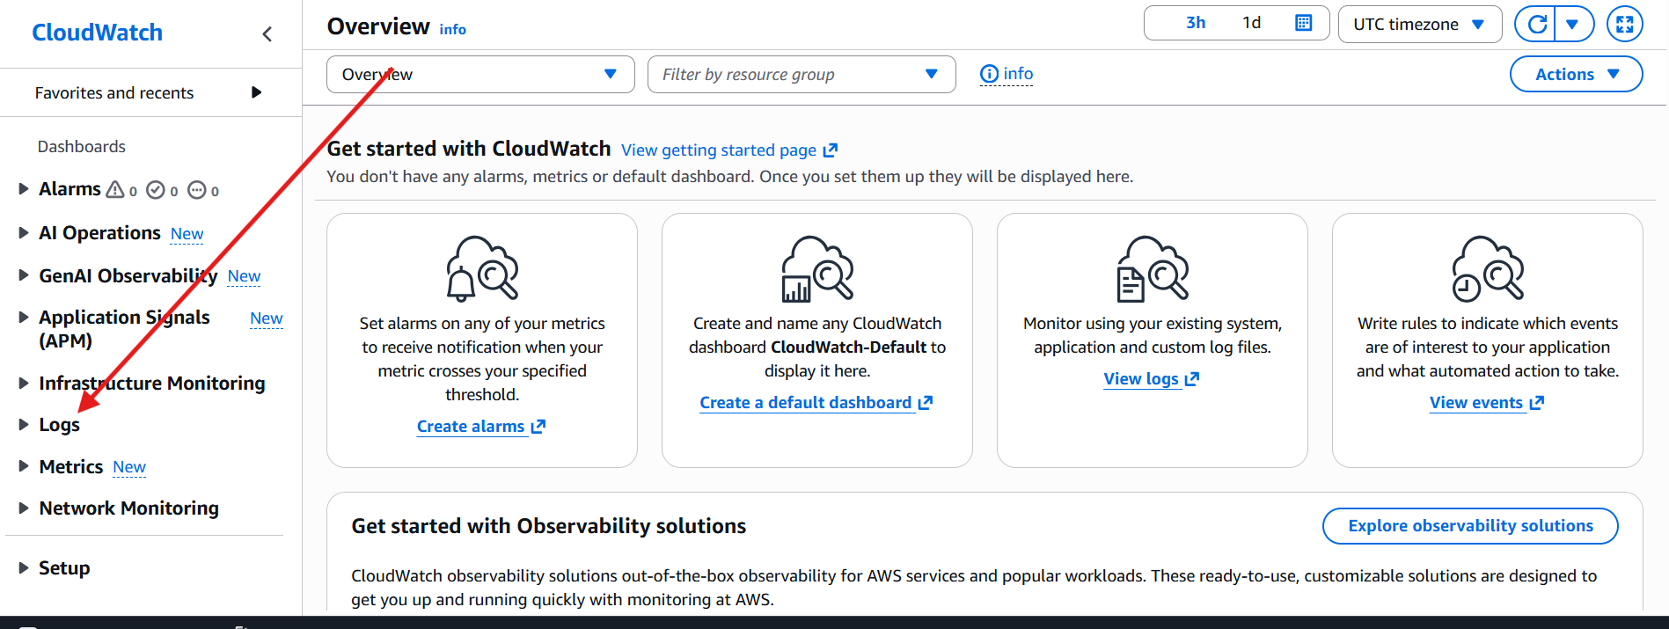

After clicking the logs

Next log groups

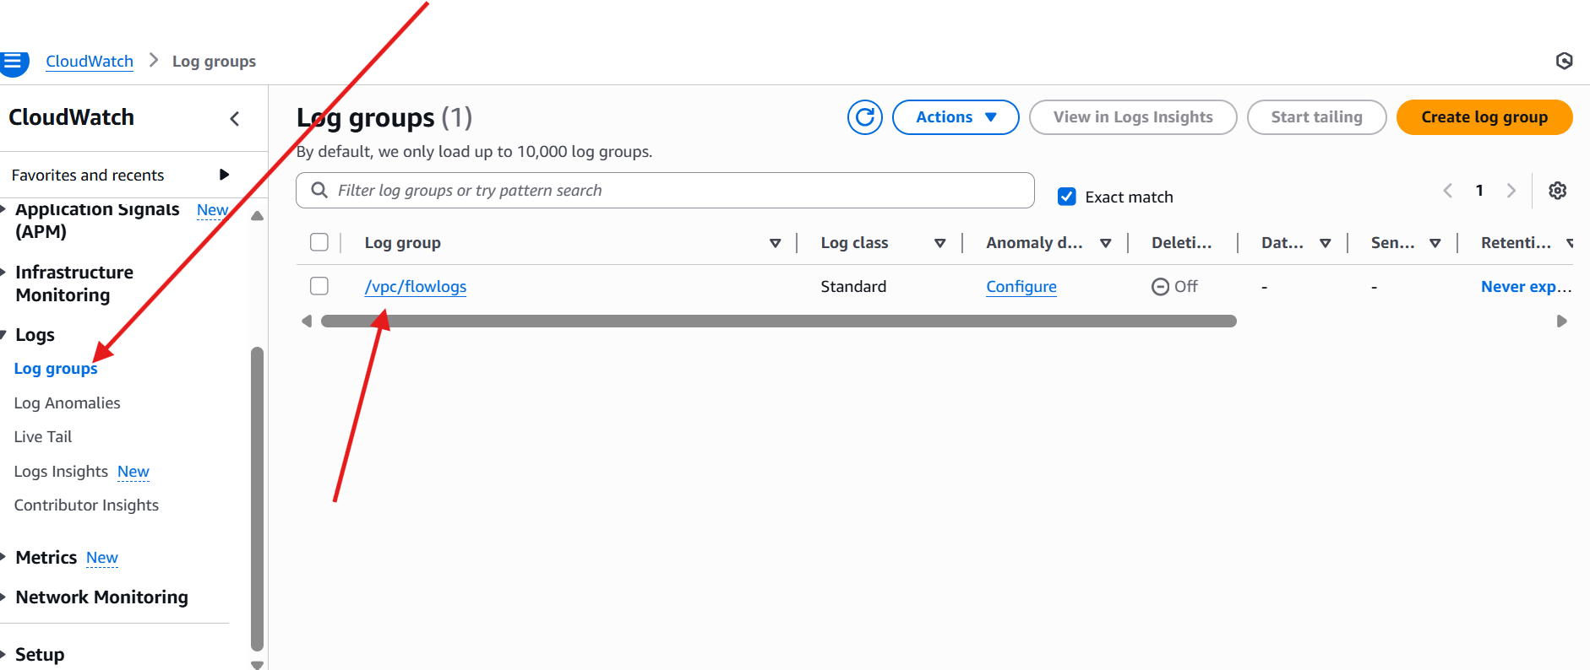

Click the /vpc/flowlogs

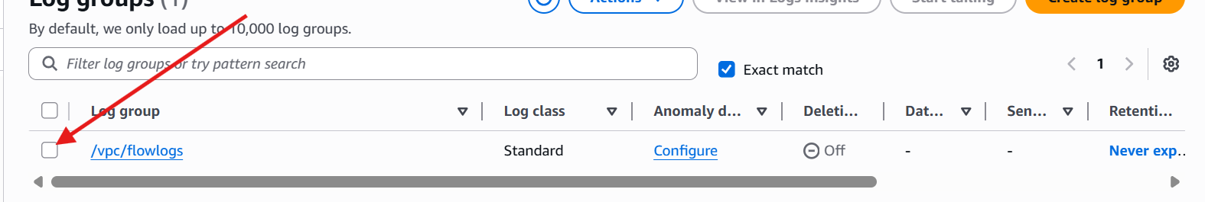

Click on log streams

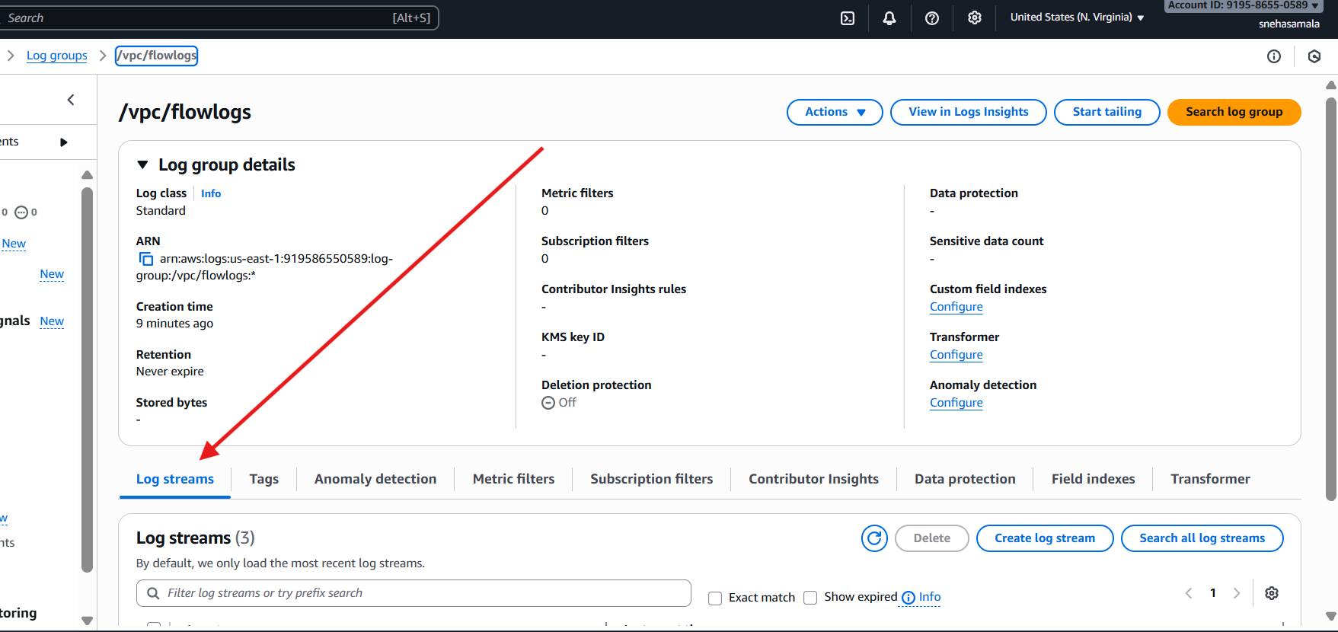

Click the log streams

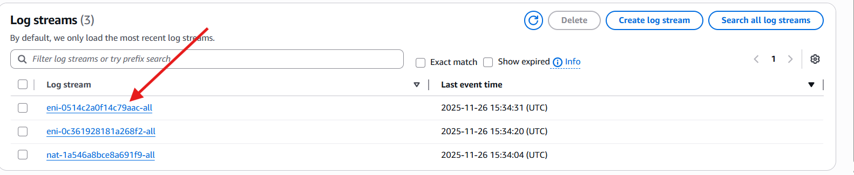

Hear the log events

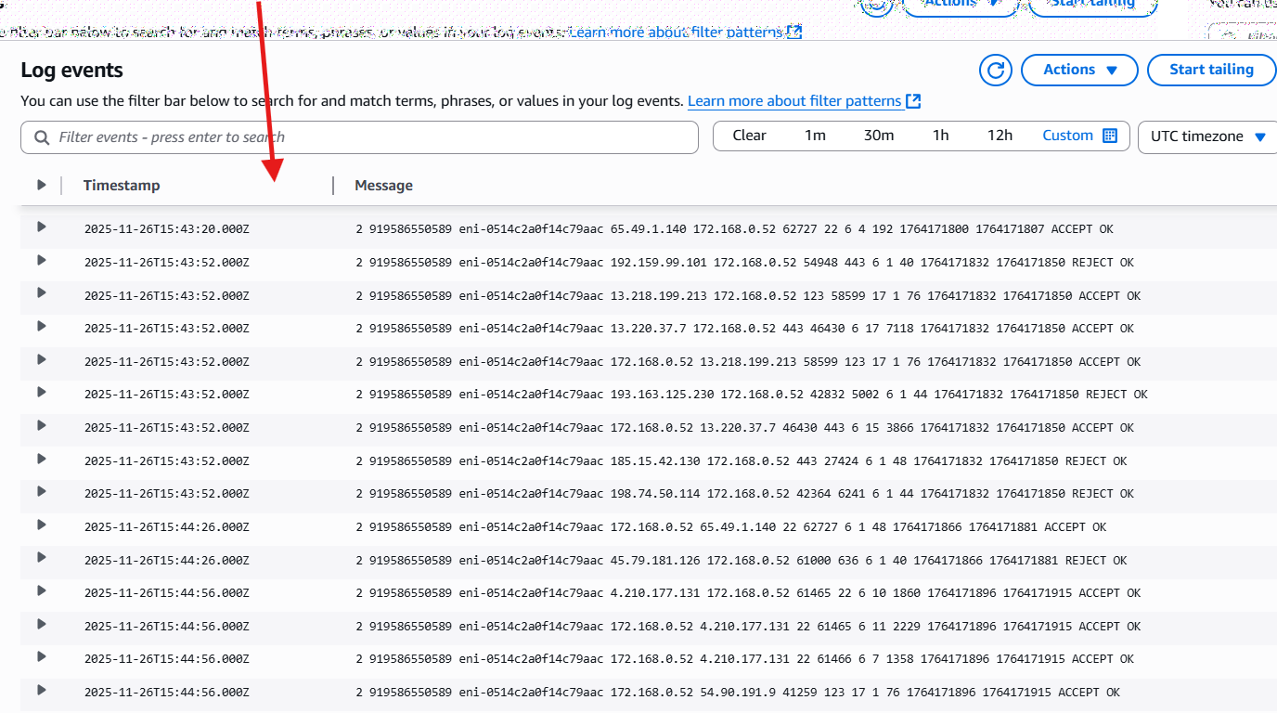

I AM USING TO S3 ALSO

Created s3 bucket successfully

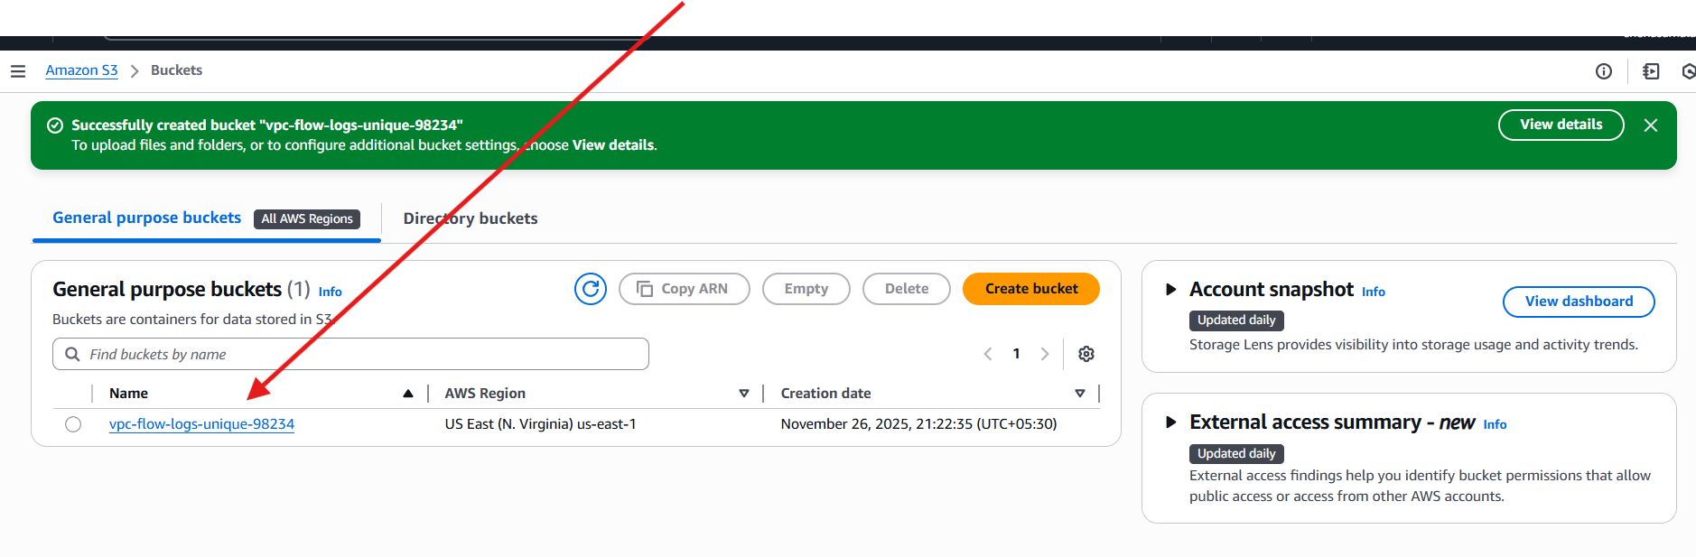

Go to vpc – select actions-vpc flow logs

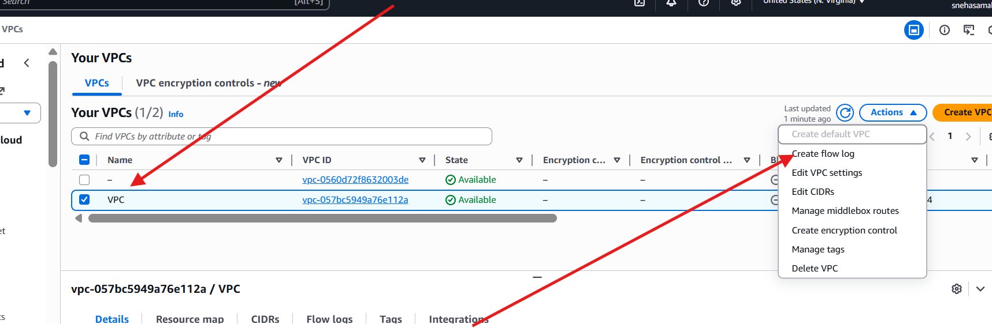

Give the flow log name

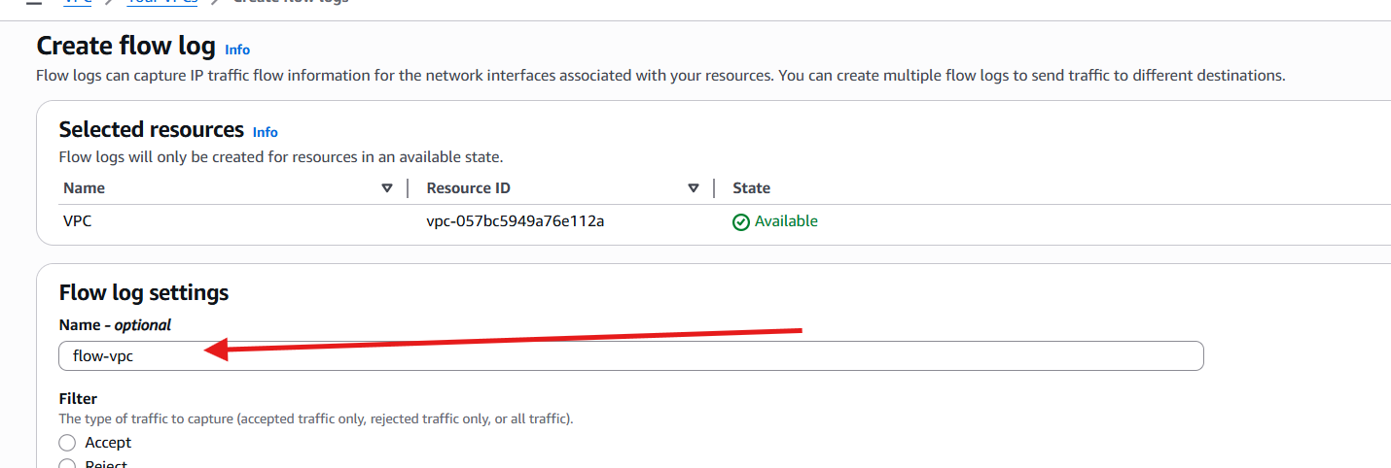

Destination log group : /vpc/flowlog

Service role name : defaltly it will come before that choose create the user new server role

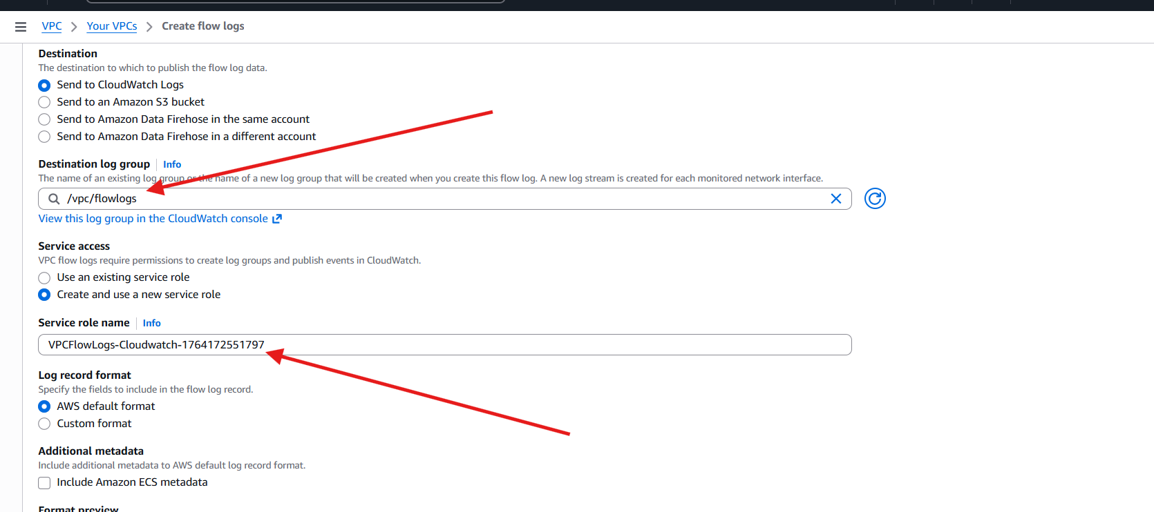

Go to the cloud watch and check the log flows

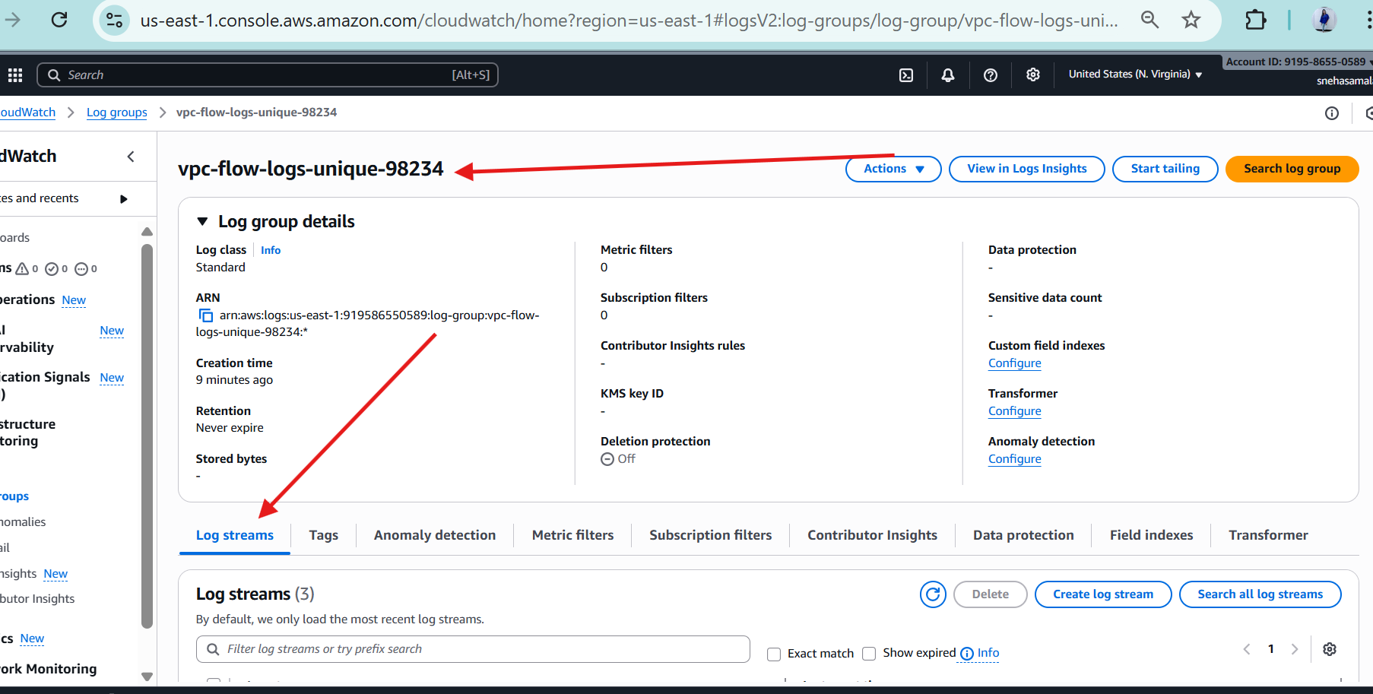

Choose any one

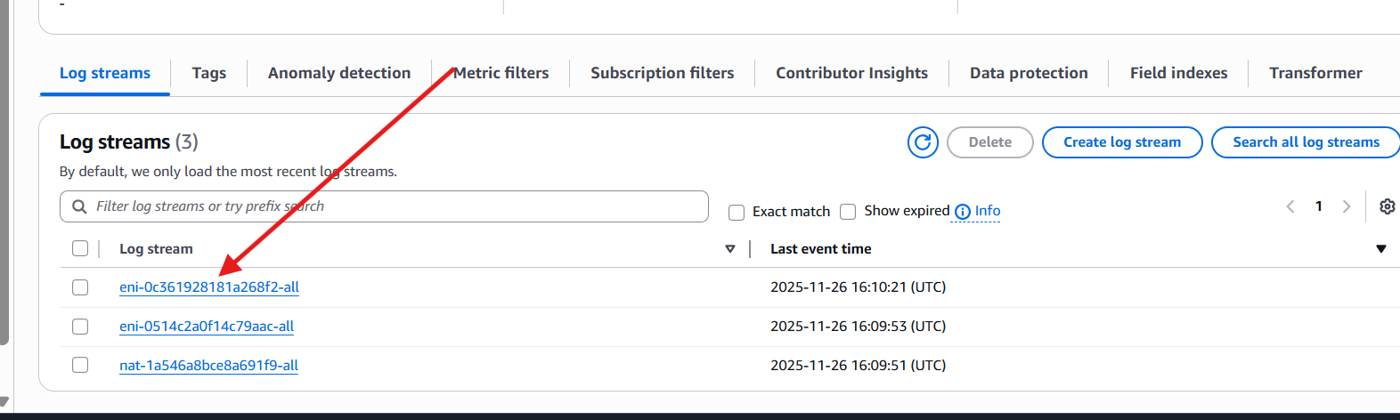

Hear the log files

